2.2.3 Exercise 1 – INFRARED SPECTROSCOPY
- Explain how infra-red spectra are produced.

- Explain what can be deduced from:

- The left-hand side of the spectrum (1500 cm⁻¹ – 4000 cm⁻¹)

- The right-hand side of the spectrum (500 cm⁻¹ – 1500 cm⁻¹)

- Identify the functional groups present in the molecules responsible for the following spectra:
Molecule A
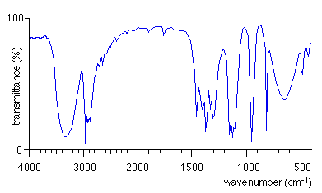
Molecule B
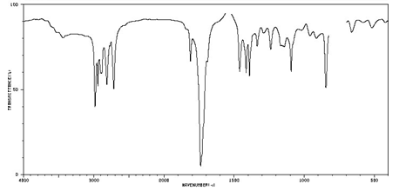

Molecule C
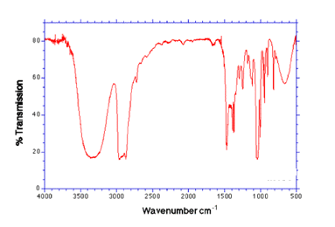
Molecule D
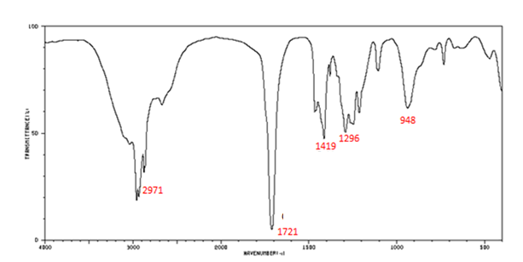
Molecule E
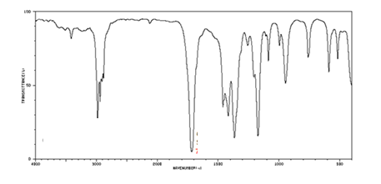

Molecule F
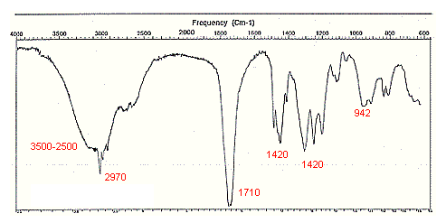

- Give an important use for infra-red spectroscopy

