DEPARTMENT OF CHEMISTRY
FOURAH BAY COLLEGE – UNIVERSITY OF SIERRA LEONE

CHEM 111

PRINCIPLES OF PHYSICAL AND INORGANIC CHEMISTRY

Unit 1 – Moles, Formulae and Equations

CONTINUOUS ASSESSMENT
TEST

8.00 am – 8.55 am
Tuesday 10th April 2018

Name: ……………………………………………………

Registration No. ……………….. (you get this from the FBC registry)

Note:
Unit 1 Continuous Assessment is worth 15% of the total marks for CHEM111
Your score will be divided into three parts:
Lecture and Tutorial Attendance 10%
Assignment 40%
Test 50%

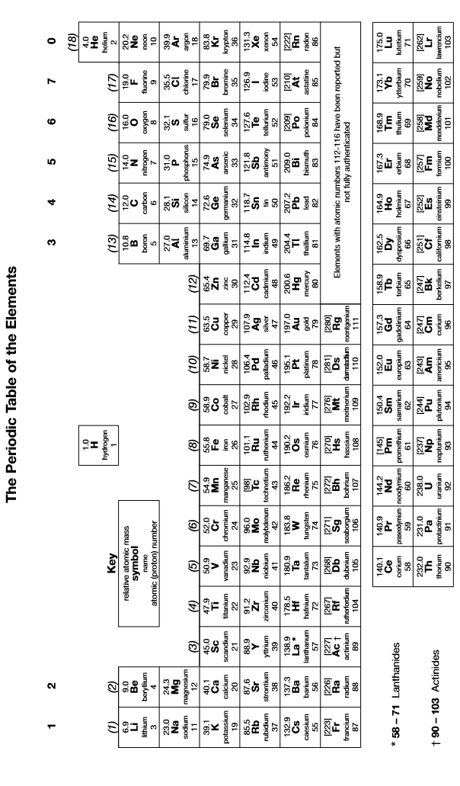

Ensure you present your answers to an appropriate number of significant figures
Use the atomic masses given in your Periodic Table (ie to 1 dp)
Molar gas constant R = 8.31 JK⁻¹mol⁻¹, Avogadro’s number L = 6.02 x 10²³ mol⁻¹
1. | Deduce the unit formulae of the following ionic compounds:
 | (a) | lead (IV) oxide
 | (b) | lithium carbonate
 | (c) | barium nitrate
 | (d) | ammonium sulphate
 | (e) | calcium nitride | [5]
2. | A hydrated ionic compound is found to contain 17.0% calcium, 11.9% nitrogen, 67.7% oxygen and 3.4% hydrogen. Deduce its empirical formula and suggest a possible unit formula for the compound.  [5]

3. | A bottle of concentrated nitric acid is labelled as containing 65% HNO₃ and 35% water by mass and a density of 1.4 gcm⁻³
 | (a) | Calculate the molarity of the nitric acid.
 | (b) | Calculate the pH of this solution, assuming that the acid is fully dissociated.  [5]
4. | Magnesium nitrate decomposes on heating at 300 ºC and 100 kPa as follows:  2Mg(NO₃)₂(s) 2MgO(s) + 4NO₂(g) + O₂(g)  If 10.0 g of Mg(NO₃)₂ is heated at 300 ºC and 100 kPa until it fully decomposes, calculate:
 | (a) | The volume of NO₂ evolved
 | (b) | The volume of O₂ evolved
 | (c) | The total volume of gas evolved  [5]

5. | When 0.80 g of calcium carbonate (CaCO₃) was dropped into 50 cm³ of 0.20 moldm⁻³ HCl, the following chemical reaction took place and went to completion:  CaCO₃ + 2HCl CaCl₂ + CO₂ + H₂O
 | (a) | Deduce which of the reactants is in excess.
 | (b) | Calculate the volume of carbon dioxide produced during the reaction under the conditions in which the molar gas volume is 24.4 dm³.  [5]
6. | Most alcohol in Africa is produced by the fermentation of glucose (C₁₆H₁₂O₆) according to the following reaction: C₆H₁₂O₆ 2C₂H₆O + 2CO₂  In one production attempt 250 kg of glucose was found to produce 107 kg of ethanol.
 | (a) | Deduce the percentage atom economy of this reaction for the production of ethanol.
 | (b) | Calculate the percentage yield of ethanol in this production attempt.  [5]

7. | Sodium carbonate reacts with hydrochloric acid according to the following equation:  Na₂CO₃(s) + 2HCl(aq) → 2NaCl(aq) + CO₂(g) + H₂O(l)  A 2.43 g sample of hydrated sodium carbonate (Na₂CO₃.xH₂O) was dissolved in distilled water to make 250 cm³ of solution. A 25.0 cm³ portion of this solution required 17.0 cm³ of 0.100 moldm^{–3} hydrochloric acid for complete reaction. Calculate the value of x.  [5]
8. | Calculate the pH of the solution formed when 25.0 cm³ of 0.150 mol dm^{–3} aqueous hydrochloric acid is added to 10.0 cm³ of 0.200 mol dm^{–3} aqueous potassium hydroxide at 25 °C.  [5]

9. | Write equations for the following reactions:
 | (a) | barium carbonate and nitric acid
 | (b) | ammonia and sulphuric acid
 | (c) | phosphoric acid (H₃PO₄) with sodium hydroxide in a 1:2 ratio
 | (d) | hydrochloric acid and aluminium hydroxide
 | (e) | Sodium hydrogencarbonate with itself  [5]

