DEPARTMENT OF CHEMISTRY
FOURAH BAY COLLEGE – UNIVERSITY OF SIERRA LEONE

CHEM 221

P-BLOCK CHEMISTRY AND FURTHER REACTIVITY

Unit 1 – The Chemistry of the p-block

CONTINUOUS ASSESSMENT
TEST

10.00 am Monday 27th August

Name: ……………………………………………………

Adm/Reg No. ………………..

Unit 1 Continuous Assessment is worth 15% of the total marks for CHEM 221
Your score will be divided into three parts:
Lecture and Tutorial Attendance 10%
Assignment 40%
Test 50%

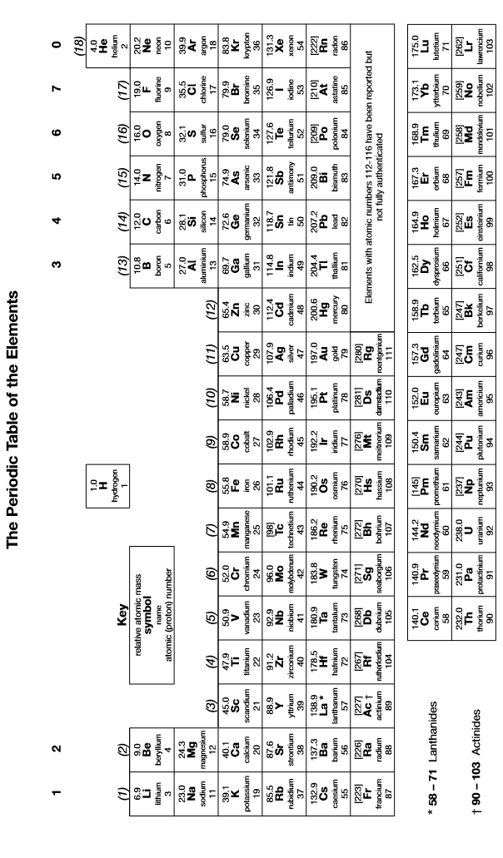
You may tear this page out but you must not write on it and must hand it in with the rest of your paper
1. | Write equations for the reaction of aluminium and thallium with dilute nitric acid. State the oxidation numbers of aluminium and thallium in the salts formed and explain any differences.  …………………………………………………………………………………………………………………………………………………………………………  …………………………………………………………………………………………………………………………………………………………………………  …………………………………………………………………………………………………………………………………………………………………………  …………………………………………………………………………………………………………………………………………………………………………  …………………………………………………………………………………………………………………………………………………………………………  …………………………………………………………………………………………………………………………………………………………………………  …………………………………………………………………………………………………………………………………………………………………………  …………………………………………………………………………………………………………………………………………………………………………  …………………………………………………………………………………………………………………………………………………………………………  [5]
2. | Aluminium chloride and boron fluoride are both covalent halides but have different structures in the gas phase. Describe the structure and bonding in both compounds and comment on any differences.  …………………………………………………………………………………………………………………………………………………………………………  …………………………………………………………………………………………………………………………………………………………………………  …………………………………………………………………………………………………………………………………………………………………………  …………………………………………………………………………………………………………………………………………………………………………  …………………………………………………………………………………………………………………………………………………………………………  [5]

3. | (a) | Aluminium oxide is amphoteric. Write equations to show how aluminium oxide reacts with hydrochloric acid and with sodium hydroxide.  ………………………………………………………………………………………………………………………………………………………………  ………………………………………………………………………………………………………………………………………………………………  ………………………………………………………………………………………………………………………………………………………………  ………………………………………………………………………………………………………………………………………………………………  ………………………………………………………………………………………………………………………………………………………………
 | (b) | Boron oxide is not amphoteric. State the acid-base character of boron oxide and explain why it is different from aluminium oxide.  ………………………………………………………………………………………………………………………………………………………………  ………………………………………………………………………………………………………………………………………………………………  ………………………………………………………………………………………………………………………………………………………………  [5]
4. | Describe, with the aid of a diagram, the structure and bonding in diborane.  …………………………………………………………………………………………………………………………………………………………………………  …………………………………………………………………………………………………………………………………………………………………………  …………………………………………………………………………………………………………………………………………………………………………  …………………………………………………………………………………………………………………………………………………………………………  …………………………………………………………………………………………………………………………………………………………………………  [5]

5. | (a) | Explain why carbon forms a stable monoxide but silicon does not.  ………………………………………………………………………………………………………………………………………………………………  ………………………………………………………………………………………………………………………………………………………………  ………………………………………………………………………………………………………………………………………………………………  ………………………………………………………………………………………………………………………………………………………………  ………………………………………………………………………………………………………………………………………………………………
 | (b) | Write an equation to show how SiCl₄ reacts with water and explain why CCl₄ does not react with water.  ………………………………………………………………………………………………………………………………………………………………  ………………………………………………………………………………………………………………………………………………………………  ………………………………………………………………………………………………………………………………………………………………  ………………………………………………………………………………………………………………………………………………………………  ………………………………………………………………………………………………………………………………………………………………  [5]
6. | Describe the structure and bonding in the two main allotropes of carbon.  …………………………………………………………………………………………………………………………………………………………………………  …………………………………………………………………………………………………………………………………………………………………………  …………………………………………………………………………………………………………………………………………………………………………  …………………………………………………………………………………………………………………………………………………………………………  …………………………………………………………………………………………………………………………………………………………………………  [5]

7. | (a) | Explain why PbO₂ is a good oxidising agent but SnO₂ is not.  ………………………………………………………………………………………………………………………………………………………………  ………………………………………………………………………………………………………………………………………………………………  ………………………………………………………………………………………………………………………………………………………………  ………………………………………………………………………………………………………………………………………………………………  ………………………………………………………………………………………………………………………………………………………………
 | (b) | Write equations to show how PbO₂ and SnO₂ react with hydrochloric acid. State the type of reaction occurring in each case.  ………………………………………………………………………………………………………………………………………………………………  ………………………………………………………………………………………………………………………………………………………………  ………………………………………………………………………………………………………………………………………………………………  ………………………………………………………………………………………………………………………………………………………………  ………………………………………………………………………………………………………………………………………………………………  [5]
8. | (a) | Explain why carbon has a greater tendency to catenate than silicon.  ………………………………………………………………………………………………………………………………………………………………  ………………………………………………………………………………………………………………………………………………………………  ………………………………………………………………………………………………………………………………………………………………  ………………………………………………………………………………………………………………………………………………………………  ………………………………………………………………………………………………………………………………………………………………
 | (b) | Explain why silicate rocks tend to be polymeric but carbonate rocks tend not to be.  ………………………………………………………………………………………………………………………………………………………………  ………………………………………………………………………………………………………………………………………………………………  ………………………………………………………………………………………………………………………………………………………………  ………………………………………………………………………………………………………………………………………………………………  ………………………………………………………………………………………………………………………………………………………………  [5]

