HIGH RESOLUTION PROTON NMR SPECTRA
- Use the information in the table below to identify molecule A from its proton nmr spectrum:
peak | chemical shift/ppm | relative intensity | peak type
a | 2.4 | 1 | sextet
b | 2.1 | 3 | singlet
c | 1.5 | 2 | pentet
d | 1.1 | 3 | doublet
e | 0.9 | 3 | triplet

- Identify the molecule responsible for the proton nmr spectrum below:
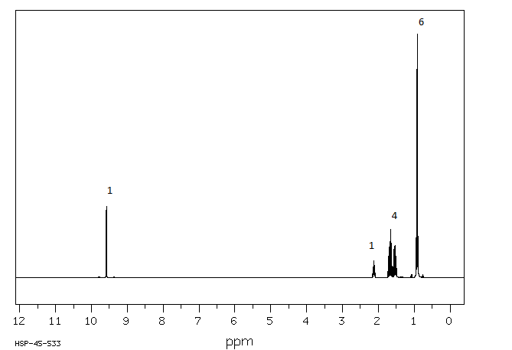
The peak at 9.6 is a doublet; the peak at 2.1 is a sextet; the peak at 1.7 is a pentet and the peak at 0.9 is a triplet
- Identify the molecule responsible for the spectrum described below:
peak | chemical shift/ppm | relative intensity | peak type
a | 8.1 | 2 | Doublet
b | 7.5 | 1 | Triplet
c | 7.4 | 2 | Triplet
d | 4.4 | 2 | Quartet
e | 1.4 | 3 | Triplet

