UNIT 7

INTRODUCTION TO ORGANIC CHEMISTRY

Student version

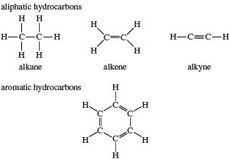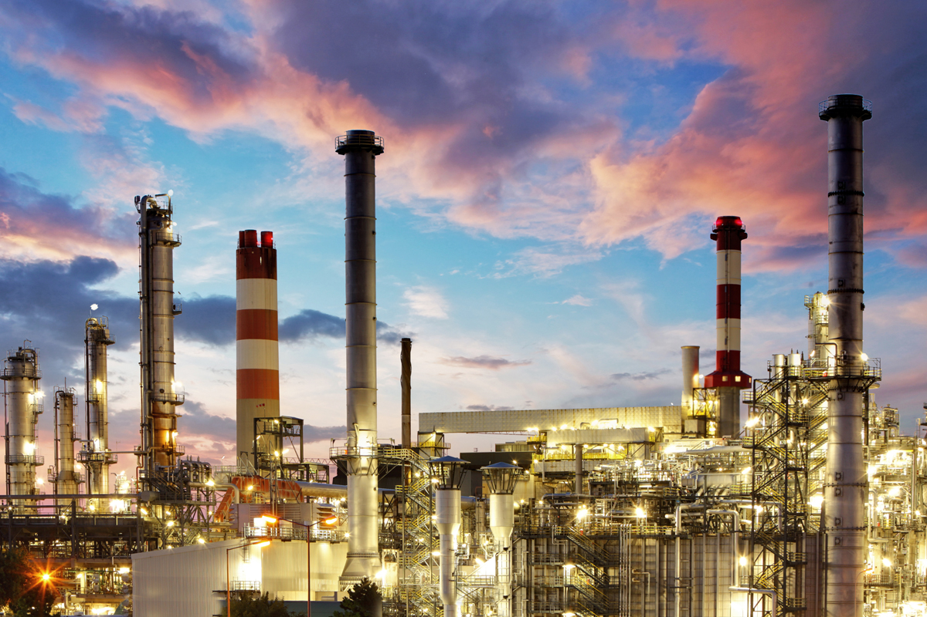

Contents

- Introducing Organic Molecules
- Isomerism
- Crude Oil
- The Combustion of Alkanes
- Preparation and Chemical Reactions of Alkanes, Alkenes and Alkynes
- Benzene and Aromatic Compounds

Key words: unbranched, branched, aliphatic, alicyclic, alkane, alkene, alkyne, haloalkane, alkanol, homologous series, structural isomerism, geometrical isomerism, stereoisomerism, petroleum, fractional distillation, cracking, reforming, combustion, fuel, petrochemical, octane number, addition, substitution, elimination, hydroxyoxidation, saturated, unsaturated, aromatic, resonance

Units which must be completed before this unit can be attempted:
Unit 1 – Atoms and the Periodic Table
Unit 2 – Particles, Structure and Bonding
Unit 3 – Amount of Substance
Unit 4 – Introduction to Physical Chemistry
Unit 5 – Acids, Bases and Salts
Unit 6 – Redox Reactions

Estimated Teaching Time: 11 hours

UNIT 7 SUMMARY AND SYLLABUS REFERENCE

Lesson | Title and Syllabus Reference
1 | Classification of Organic Compounds  CA11ai classification (broad classification into straight chain, branched chain and alicyclic compounds), CA11aii classification – functional groups, CAei alkanes (structure), CAfi alkenes (structure), CA11g alkynes (structure), CC6g alkanols, ISA13 organic compounds (hydrocarbons, alkanols, functional groups); ISA13.1 classification of compounds as inorganic or organic (differences between inorganic and organic compounds)
2 | Drawing and Representing Organic Compounds  ISA13 organic compounds (hydrocarbons (first four members in each group), alkanols (methanol, ethanol, propanol), functional groups); CC6g alkanols (recognition of the structures of mono-, di- and triols)
3 | Nomenclature of Organic Compounds I  CA11ai nomenclature – root names; CA11aii nomenclature – functional groups (systematic nomenclature of the following compounds: alkanes, alkenes, alkynes and alkanols); CA11ei alkanes (nomenclature); CA11fi alkenes (nomenclature); CA11g alkynes (nomenclature); CC6g alkanols; CA11i.i alkanols – nomenclature and structure; ISA4.3 ionic and covalent compounds (IUPAC names of common compounds); ISA13 organic and inorganic compounds (hydrocarbons (first four members in each group), alkanols (methanol, ethanol, propanol), functional groups)
4 | Nomenclature of Organic Compounds II; Homologous Series  CA3 van der Waal’s forces (variation of the melting points and boiling points of alkanes in a homologous series explained in term of van der Waal’s forces); CA11ai nomenclature – root names; CA11aii nomenclature – functional groups (systematic nomenclature of the following compounds: alkanes, alkenes, alkynes and alkanols); CA11di general properties – homologous series (gradation in physical properties, effects on the physical properties by introduction of active groups into the inert alkane); CA11ei alkanes (nomenclature); CA11fi alkenes (nomenclature); CA11g alkynes (nomenclature); CC6g alkanols (recognition of the structures of mono-, di- and triols); ISA4.3 ionic and covalent compounds (IUPAC names of common compounds)
5 | Isomerism (Structural)  CA11dii general properties – isomerism (examples should be limited to compounds having maximum of five carbon atoms)
6 | Isomerism (Geometric)  CA11dii general properties – isomerism (examples should be limited to compounds having maximum of five carbon atoms, differences between structural and geometric/stereo isomerism)
7 | Crude Oil  CA11ei alkanes – sources and properties (industrial preparations and other sources, cracking of large alkane molecules); CA11eii alkanes – uses (importance as fuels, as starting materials for synthesis); CA11eiii petroleum (composition, fractional distillation and major products, cracking and reforming, petrochemicals: starting materials of organic synthesis); ISA13 organic and inorganic compounds (hydrocarbons, properties and uses of organic compounds); ISA13.1 classification of chemicals as organic and inorganic (Importance of organic chemistry in industrialization); ISA13.3 petrochemicals (sources of petrochemicals, the refinery of crude oil)

Lesson | Title and Syllabus Reference
8 | Alkanes as Fuels  CA11ei alkanes – properties (combustion); CA11eii alkanes – uses (importance as fuels, pollution effects); CA11eiii petroleum (quality of petrol, meaning of octane number); ISA13 organic and inorganic compounds (hydrocarbons, properties and uses of organic compounds); ISA13.1 classification of chemicals as organic and inorganic (importance of organic chemistry in industrialization); ISA13.3 petrochemicals (application and effects of petrochemicals on the environment); ISE2.2 human activities and their effects on the atmosphere (effects of human activities on the atmosphere: air transport, industrialization); ISE2.4 atmospheric pollutants (sources and effects of the following major pollutants: oxides of nitrogen and sulphur); ISE2.5 greenhouse effect (explanation of ‘greenhouse’ and its effect: global warming and climate change, greenhouse gases eg carbon (IV) oxide); ISE2.6 acid rain (identification of acidic pollutants which cause acid rain, the effects of acid rain on the environment (damage to buildings, paints forests etc))
9 | Chemical Properties of Alkanes, Alkenes and Alkynes  CA11ei alkanes – sources and properties (laboratory preparation, substitution reactions); CA11eii alkanes – uses (uses of haloalkanes and pollution effects); CA11fi alkenes – sources and properties (laboratory preparation, addition reactions with halogens, bromine water, hydrogen halides, oxidation: hydroxylation with aqueous KMnO₄); CA11fii alkenes – laboratory detection (use of reaction with Br₂/CCl₄ and KMnO₄(aq) as means of characterising alkenes); CA11g alkynes – sources and uses (industrial production of ethyne, uses of ethyne); CA13cv characteristic test tube reactions of the functional groups in the following simple organic compounds: alkenes; CC6e alkynes – chemical properties (tests to distinguish between alkanes, alkenes and alkynes); ISA13 organic and inorganic compounds (hydrocarbons (first four members in each group), functional groups, properties and uses of organic compounds); ISE2.5 ozone layer (sources and effects of CFCs on the ozone layer)
10 | Benzene and Aromatic Compounds  CA11ai classification (broad classification into straight chain, branched chain, aromatic and alicyclic compounds); CA11hi benzene - structure and physical properties; CA11hii benzene – chemical properties (resonance in benzene, stability leading to substitution reactions, halogenations (mechanism not required), addition reactions: hydrogenation and halogenation, compare reactions with those of alkenes); CC6f benzene – uses
11 | Unit 7 Revision and Summary

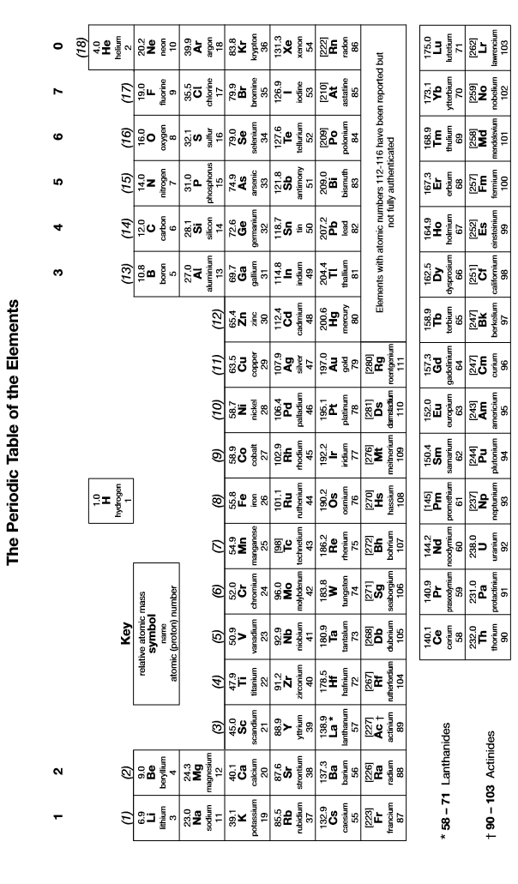

Lesson 1 – What are organic molecules?

- Introducing Organic Molecules

- Overview

- Organic chemistry is the chemistry of carbon compounds; carbon forms a vast number of compounds because it can form strong covalent bonds with itself; this enables it to form long chains (up to 5000 in length) of carbon atoms, and hence an almost infinite variety of carbon compounds are possible

- An organic compound is a substance containing at least one carbon atom and usually containing at least one C-H covalent bond; generally all compounds involving carbon are described as organic except for carbon dioxide and carbonates; a compound not classified as an organic compound is an inorganic compound; inorganic chemistry is the chemistry of all elements and compounds which are not organic

- Most living organisms are composed largely of organic molecules; organic Chemistry thus forms the basis for Biochemistry – the Chemistry of Living Organisms

- All organic compounds contain carbon; most contain hydrogen and some contain oxygen

- In every molecule, each carbon atom always forms four covalent bonds; each hydrogen atom always forms one covalent bond and each oxygen atom always forms two covalent bonds

- Describing and classifying organic molecules

When describing an organic molecule, there are two main things to consider:

- the number and arrangement of carbon atoms in the molecule
- the total number of carbon atoms in a molecule can vary from 1 to more than 1,000,000
- in many cases, all the carbon atoms are arranged in an unbranched chain; often, however, molecules contain shorter chains of carbon atoms branching off a longer chain; these are known as branched molecules
Eg
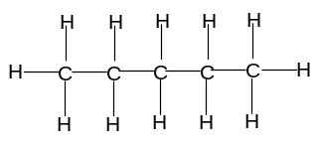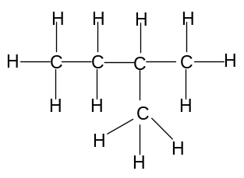
Unbranched molecule Branched molecule
- carbon atoms can also be arranged to form rings; these are known as alicyclic molecules; the most common number of carbon atoms in a ring is 6; molecules which do not contain a ring are known as aliphatic molecules
Eg
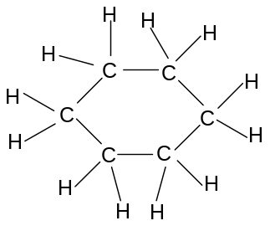
Alicyclic molecule Aliphatic molecule
- the functional groups in the molecule
- a functional group is a specific atom or group of atoms which confer certain physical and chemical properties onto the molecule
- organic molecules are classified by the dominant functional group on the molecule
- the most common functional groups found on organic molecules:

Type of compound | Description of functional group | Diagram of functional group
Alkane | C-C and C-H single bonds only (ie no functional group) | 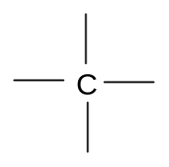
Alkene | C=C double bond | 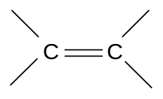
Alkyne | C≡C triple bond | -C≡C-
Haloalkane  -Chloroalkane  -Bromoalkane  -Iodoalkane | Cl, Br or I atom attached to a carbon atom | 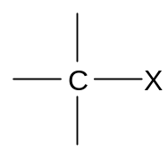
Alcohol | O atom in between a C atom and an H atom | 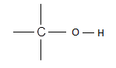

- molecules which contain carbon and hydrogen only are known as hydrocarbons; alkanes, alkenes and alkynes are examples of hydrocarbons; haloalkanes and alcohols are not hydrocarbons
- an alicyclic alkane is called a cycloalkane; an alicyclic alcohol is called a cycloalcohol, etc

Test your knowledge 1.1: Classifying simple organic molecules
For each of the molecules below:
- identify the functional group
- indicate whether the molecule is branched or unbranched
- Indicate whether the molecule is aliphatic or alicyclic
- Indicate whether or not the molecule is a hydrocarbon
(i)  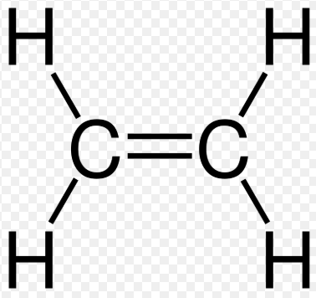 | (ii)  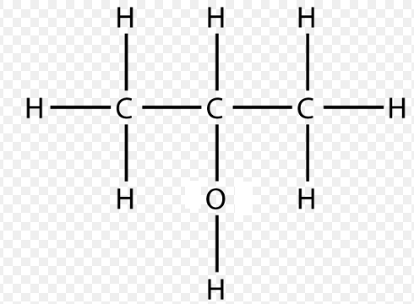 | (iii)  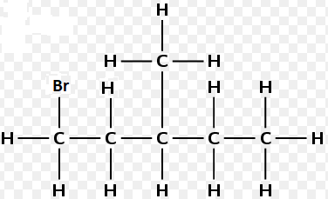
(iv)  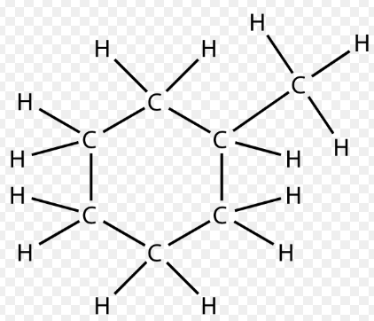 | (v)  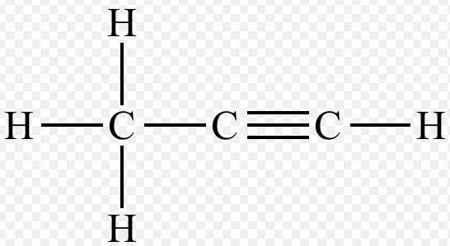 | (vi)  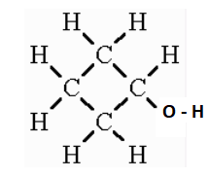
(vii)  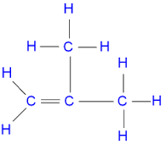 | (viii)  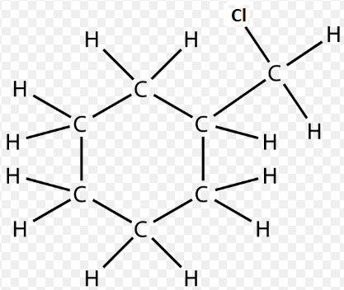 | (ix)  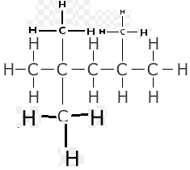

Lesson 2 – How can we draw and write organic molecules?

- Drawing and writing organic molecules

Organic compounds can be represented in a number of ways:

- Displayed formula, showing all covalent bonds; this is also known as the graphical formula; all covalent and ionic bonds between all atoms are shown:
eg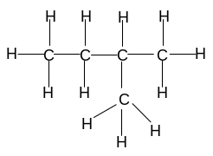

- Structural formula, not showing covalent bonds; enough information is shown to make the structure clear, but the actual covalent bonds are omitted
Unbranched alkanes are shown as follows:
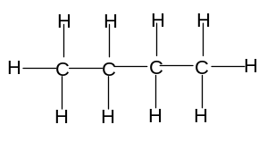is represented as CH₃CH₂CH₂CH₃ or CH₃(CH₂)₂CH₃

Branched alkanes are shown as follows:
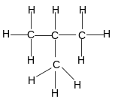is represented as CH₃CH(CH₃)CH₃
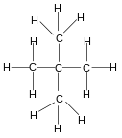is represented as CH₃C(CH₃)₂CH₃

Alkenes are shown as follows:
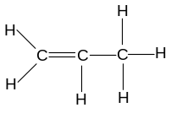is represented as CH₂CHCH₃
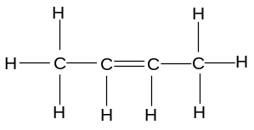is represented as CH₃CHCHCH₃

Haloalkanes are represented as follows:
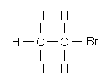 is represented as CH₃CH₂Br
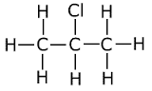is represented as CH₃CHClCH₃

Alcohols are represented as follows:
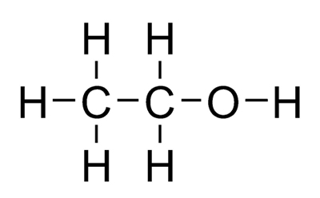is represented as CH₃CH₂OH
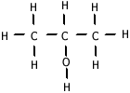is represented as CH₃CH(OH)CH₃
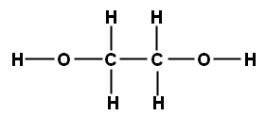 is represented as HOCH₂CH₂OH

- Skeletal formula, not showing carbon atoms; skeletal formulae are a useful simplified way of drawing organic molecules:
  - carbon atoms are not drawn – they are represented by a dot
  - hydrogen atoms are not drawn if they are bonded to carbon atoms
  - covalent bonds are represented by a line if they do not involve hydrogen
  - covalent bonds involving hydrogen are omitted
  - the angle between the bonds must be correct (109º if tetrahedral, 120º if planar) (see Unit 2 – Particles, Bonding and Structure)

 | is represented as | 
 | is represented as | 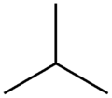
 | is represented as | 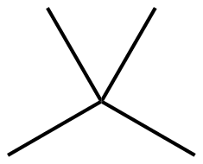
 | is represented as | 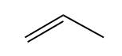
 | is represented as | 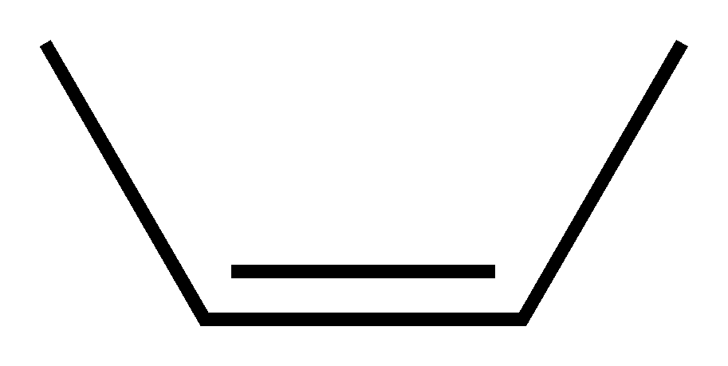
 | is represented as | 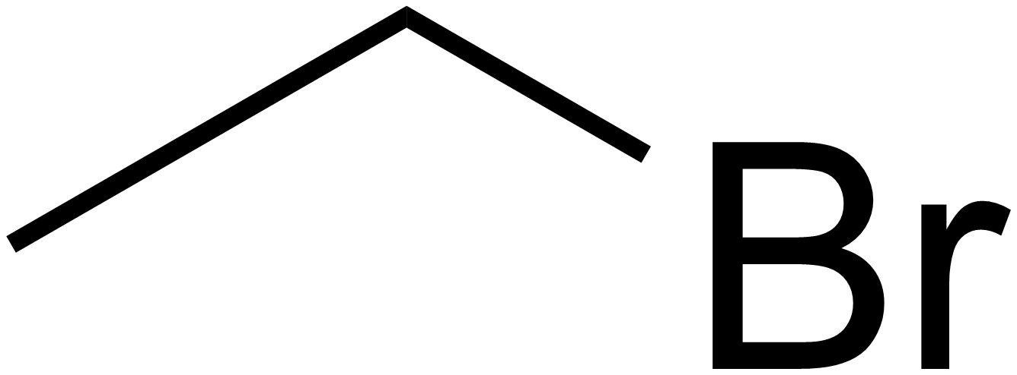
 | is represented as | 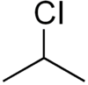
 | is represented as | 
 | is represented as | 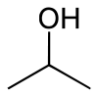
 | is represented as | 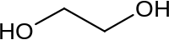
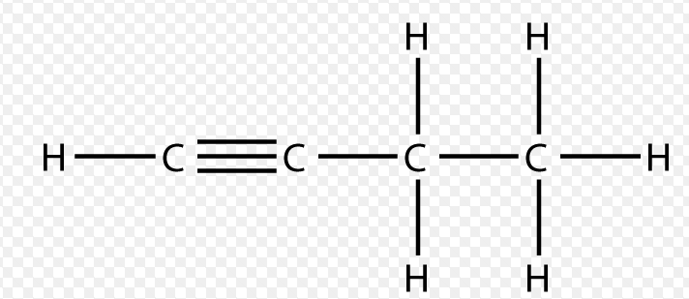 | is represented as | 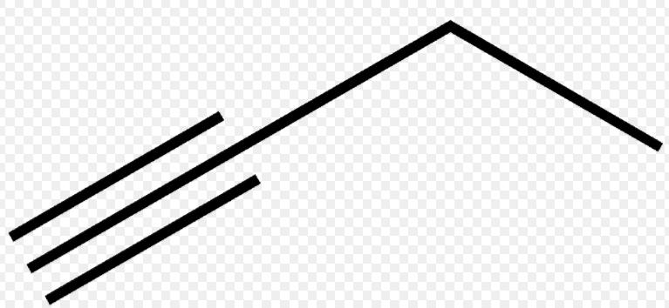

Note: it is common to see structures drawn as a combination of displayed, structural and skeletal formulae

- Molecular formula; this shows the number of each atom in one molecule of the compound (see Unit 2 – Particles, Bonding and Structure); it does not show unequivocally the structure of the molecule, so different molecules can have the same molecular formula; molecules with the same molecular formula but different structures are known as isomers

is written C₄H₁₀ is written C₄H₈

Alkanes have the general molecular formula C_{n}H_{2n+2} (eg C₃H₈ or C₅H₁₂)
Alkenes have the general molecular formula C_{n}H_{2n} (eg C₃H₆ or C₆H₁₂)
Haloalkanes have the general molecular formula C_{n}H_{2n+1}X (eg C₄H₉Cl or C₄H₉Br)
Alcohols have the general molecular formula C_{n}H_{2n+2}O (eg C₄H₁₀O or C₆H₁₄O)

- Empirical formula; this the simplest whole number ratio of the number of atoms of each element in a substance (see unit 2 – Particles, Bonding and Structure)

Test your knowledge 2.1: Drawing simple organic molecules
- Using displayed or structural formulae, draw a compound with four carbon atoms which is:
(i) an unbranched alkane
(ii) an unbranched alicyclic alcohol (cycloalcohol)
(iii) a branched alkene
(iv) an unbranched alkyne
(v) a branched bromoalkane
- Give the molecular and empirical formula of the five compounds you have drawn in (a)
- Draw the displayed, structural, skeletal and molecular formula of a branched aliphatic alcohol with five carbon atoms
- Deduce the general molecular formula of:
(i) aliphatic alkynes
(ii) alicyclic alcohols

Lesson 3 – How do we name organic compounds?

- Most organic compounds can be named systematically by the IUPAC method; in order to describe completely an organic molecule, three features must be described:
- the longest unbranched carbon chain or ring on the molecule
- the nature and position of any functional groups on the molecule
- the length and position of any branches on the molecule

- Naming Unbranched Aliphatic Molecules

- The longest unbranched chain on the molecule is indicated by one of the following prefixes:

Number of carbon atoms in the chain | Prefix
1 | Meth-
2 | Eth-
3 | Prop-
4 | But-
5 | Pent-

- The functional group on the molecule is usually shown with a suffix at the end of the name:
Alkanes end with -ane
Alkenes end with -ene
Alkynes end with -yne
Alcohols end with – anol
Haloalkanes, however are named using a prefix (chloro-, bromo- or iodo-)

- The number of carbon atoms in the longest unbranched chain is combined with the functional group to give the name of the molecule:

Molecule |  | Name | Reason
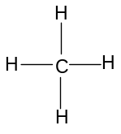 |  | Methane | meth-: longest unbranched carbon chain = 1  -ane: it is an alkane (ie it has no functional group)
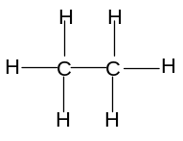 |  | Ethane | eth-: longest unbranched carbon chain = 2  -ane: it is an alkane (ie it has no functional group)
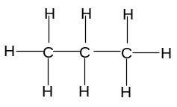 |  | Propane | prop-: longest unbranched carbon chain = 3  -ane: it is an alkane (ie it has no functional group)
 |  | Butane | but-: longest unbranched carbon chain = 4  -ane: it is an alkane (ie it has no functional group)
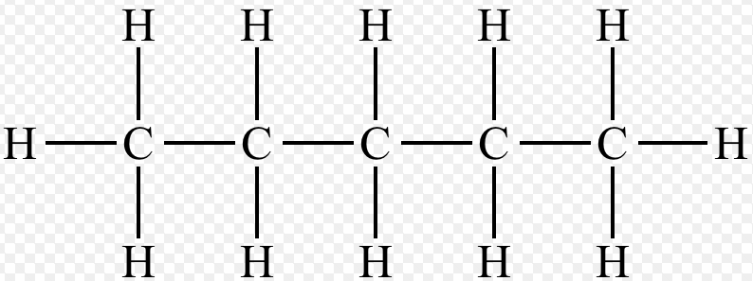 |  | Pentane | pent-: longest unbranched carbon chain = 5  -ane: it is an alkane (ie it has no functional group)
Molecule | Name |  |  | Reason
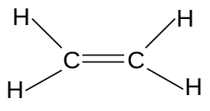 | Ethene |  |  | eth-: longest unbranched carbon chain = 2  -ene: it is an alkene
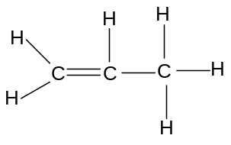 | Propene |  |  | prop-: longest unbranched carbon chain = 3  -ene: it is an alkene
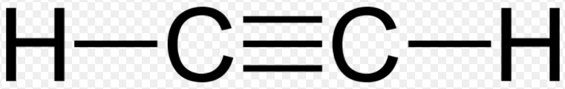 | Ethyne |  |  | eth-: longest unbranched carbon chain = 2  -yne: it is an alkyne
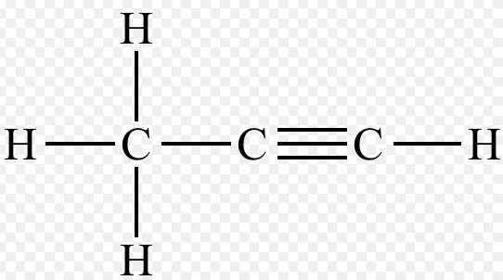 | Propyne |  |  | prop-: longest unbranched carbon chain = 3  -yne: it is an alkyne
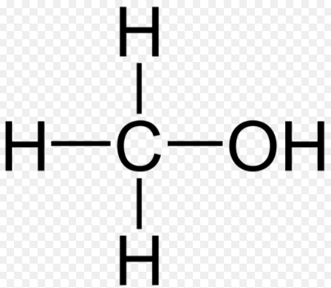 | Methanol |  |  | meth-: longest unbranched carbon chain = 1  -anol: it is an alcohol
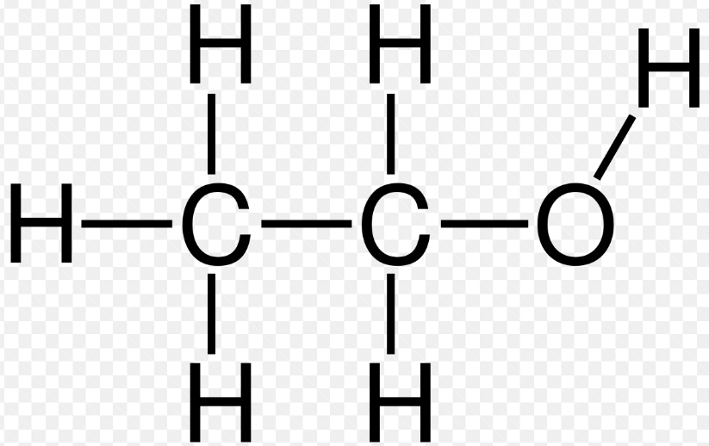 | Ethanol |  |  | eth-: longest unbranched carbon chain = 2  -anol: it is an alcohol
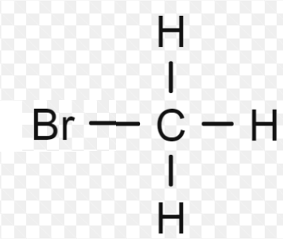 | bromomethane |  |  | -meth-: longest unbranched carbon chain = 1  bromo- -ane: it is a bromoalkane
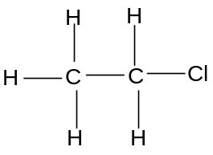 | Chloroethane |  |  | -eth-: longest unbranched carbon chain = 2  chloro- -ane: it is a chloroalkane

- In haloalkanes and alcohols containing 3 or more carbon atoms, and in alkenes or alkynes containing 4 or more carbon atoms, the functional group can exist in more than one different position on the molecule; in such cases the position of the functional group must be specified as follows:
- the carbon atoms on the unbranched chain must be numbered, starting with the end closest to the functional group
- the lowest-numbered carbon atom involved in the functional group is indicated just before the part of the name which describes the functional group:

Molecule | Name | Reason
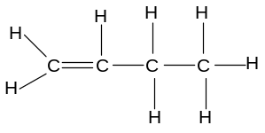 | But-1-ene | but-: longest unbranched carbon chain = 4  -ene: it is an alkene  -1-: the lowest numbered C atom involved in the C=C bond is 1
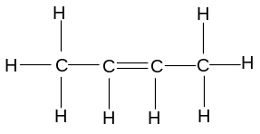 | But-2-ene | but-: longest unbranched carbon chain = 4  -ene: it is an alkene  -2-: the lowest numbered C atom involved in the C=C bond is 2
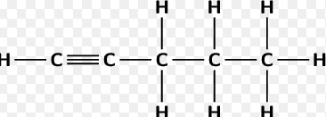 | Pent-1-yne | pent-: longest unbranched carbon chain = 5  -yne: it is an alkyne  -1-: the lowest numbered C atom involved in the C≡C bond is 1
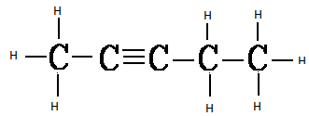 | Pent-2-yne | pent-: longest unbranched carbon chain = 5  -yne: it is an alkyne  -2-: the lowest numbered C atom involved in the C≡C bond is 2
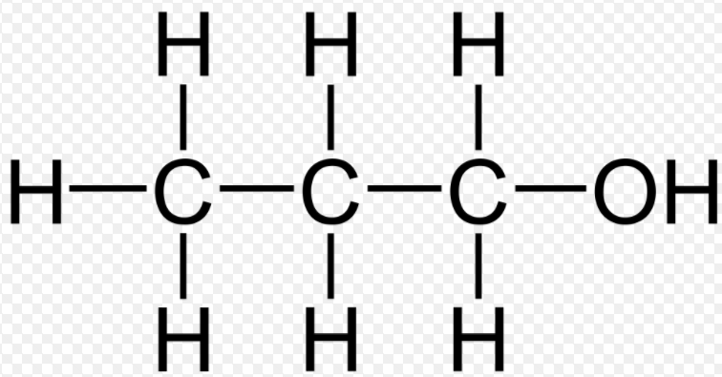 | Propan-1-ol | prop-: longest unbranched carbon chain = 3  -an-ol: it is an alcohol  -1-: the C atom attached to the O is No. 1
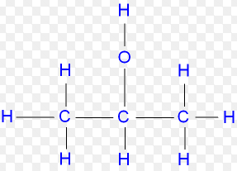 | Propan-2-ol | prop-: longest unbranched carbon chain = 3  -an-ol: it is an alcohol  -2-: the C atom attached to the O is No. 2
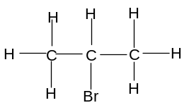 | 2-bromopropane | -prop-: longest unbranched carbon chain = 3  -bromo-ane: it is a bromoalkane  -2-: the C atom attached to the Br is No. 2
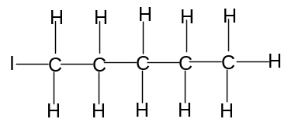 | 1-iodopentane | -pent-: longest unbranched carbon chain = 5  -iodo-ane: it is an iodoalkane  -1-: the C atom attached to the I is No. 1

- Note that but-1-ene and but-2-ene have the same molecular formula, but different structures; this means that they are isomers of each other; pent-1-yne and pent-2-yne are also isomers of each other, as are propan-1-ol and propan-2-ol

Test your knowledge 3.1: Naming simple organic molecules
- Name the following molecules:
(i) | 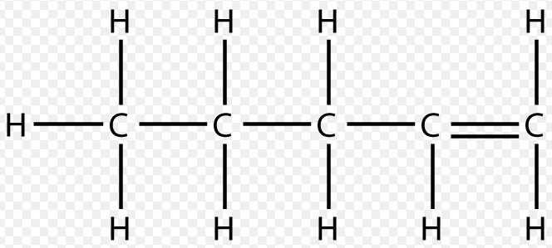 | (ii) | 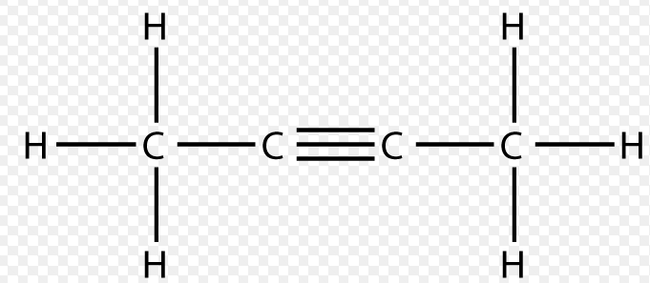 | (iii) | 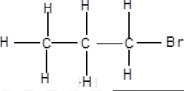
(iv) |  | (v) | 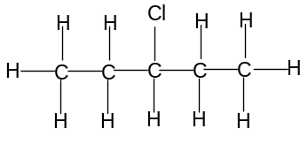 | (vi) | 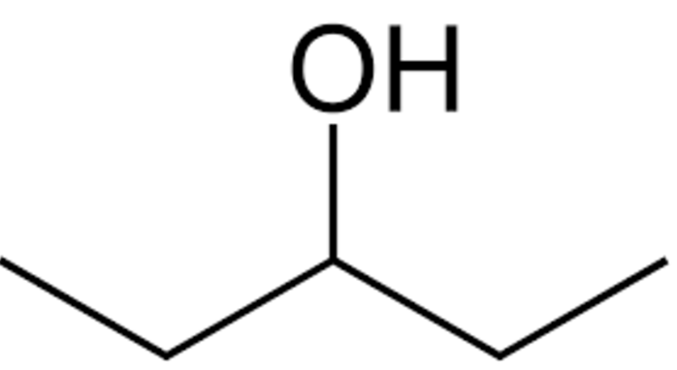
- Draw the structures of the following molecules:
(i) | Butane | (ii) | Propyne | (iii) | butan-2-ol
(iv) | 2-chloropentane | (v) | Iodomethane | (vi) | propan-1-ol

Lesson 4 – How do we name more complex organic compounds?

- Many molecules have more than one functional group; the only such molecules which will be discussed in this section are dihaloalkanes (organic molecules which contain two halogen atoms) and diols (organic molecules which contain two -OH groups)
- When naming dihaloalkanes and diols, the position of both functional groups must be specified unless there is only one carbon atom in the molecule; if there is more than one of the same type of functional group on the molecule, the di (two) prefix should be used:

Molecule | Name | Reason
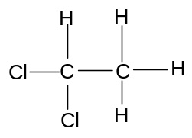 | 1,1-dichloroethane | -eth-: longest unbranched carbon chain = 2  -dichloro-ane: it is a dichloroalkane  (ie there are two Cl atoms on the molecule)  1,1-: both Cl atoms are on C No. 1
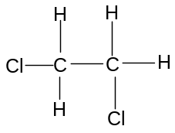 | 1,2-dichloroethane | -eth-: longest unbranched carbon chain = 2  -dichloro-ane: it is a dichloroalkane  (ie there are two Cl atoms on the molecule)  1,2-: one Cl atom is on C No. 1 and the other is on C No. 2
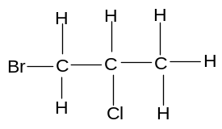 | 1-bromo,2-chloropropane | -prop-: longest unbranched carbon chain = 3  -chloro-ane: it is a chloroalkane  -bromo-ane: it is also a bromoalkene  1-: the Br is on C No. 1  2-: the Cl is on C No. 2
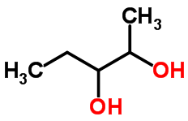 | pentan-2,3-diol | -pent-: longest unbranched carbon chain = 5  -diol: it is a diol  -2,3-: the -OH groups are attached to the 2nd and 3rd C atoms

- Naming branched Aliphatic Molecules

- Many carbon chains are branched. The presence of a branch is indicated one of the following prefixes:

Branch | Prefix
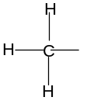 | Methyl
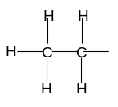 | Ethyl

- Usually, there is more than one place in which the branch can be attached; in such cases, the position of the branch must be specified according to the number of the carbon on the straight chain to which it is attached; the carbon atoms should be numbered as follows:
- the carbon atoms are numbered from the carbon at the end of the chain closest to the functional group
- if there is no functional group, the carbons are numbered from the carbon at the end of the chain closest to the branch.

Eg
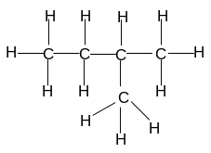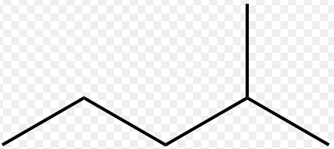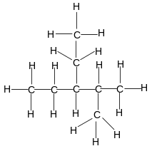
methylbutane 2-methylpentane 2-methyl,3-ethylpentane

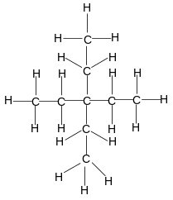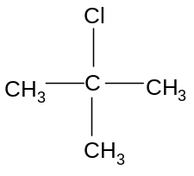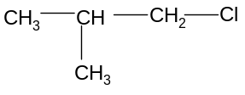
diethylpentane 2-chloromethylpropane 1-chloromethylpropane

- Naming Alicyclic Molecules

- Cyclic molecules are named using the prefix “cyclo-“ to indicate the number of unbranched carbon atoms in the ring:
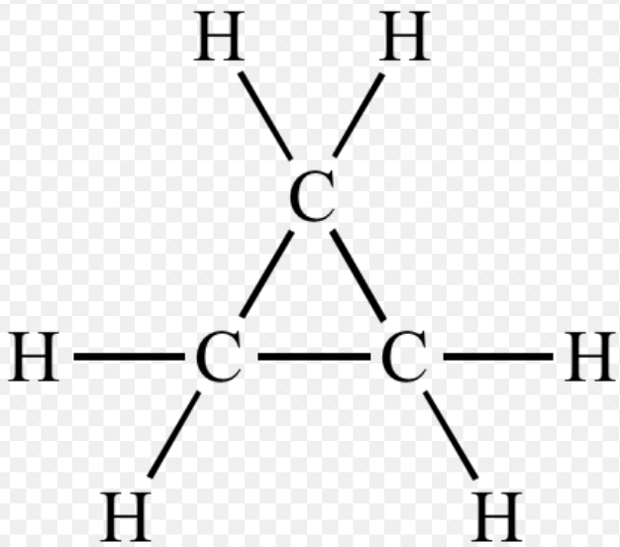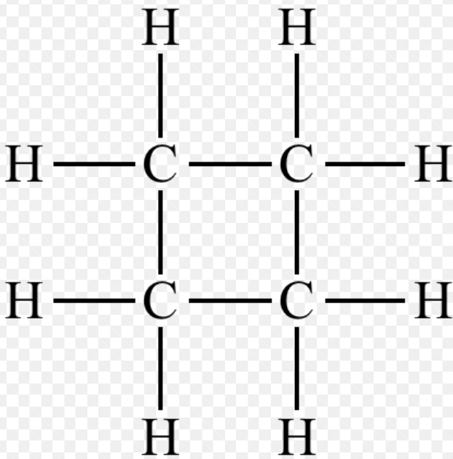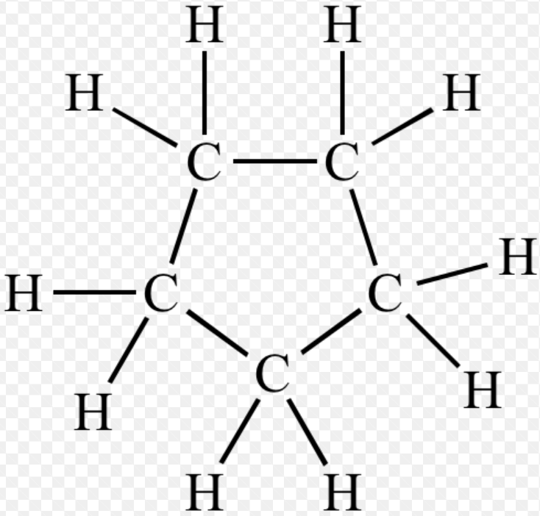
cyclopropane cyclobutane cyclopentane

- If the ring also contains functional groups or is branched, the naming rules are the same as for aliphatic molecules:
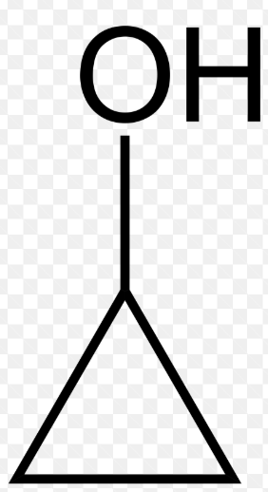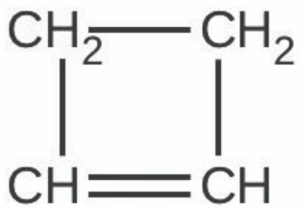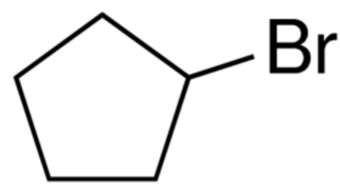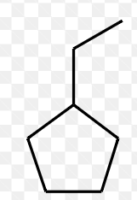
Cyclopropanol cyclobutene bromocyclopentane ethylcyclopentane

- As all the carbon atoms on the ring are identical, numbering is only necessary when there is more than one functional group or branch on the ring:
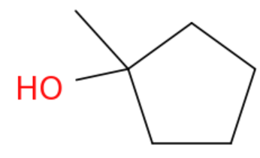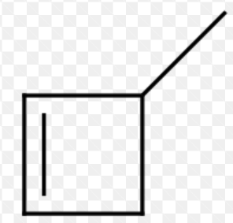
1-methylcyclopentanol 1,2-dimethylcyclobutane 3-methylcyclobutene

Test your knowledge 4.1: Naming more complex organic molecules
- Name the following molecules:
(i) | HOCH₂CH₂CH₂OH | (ii) | 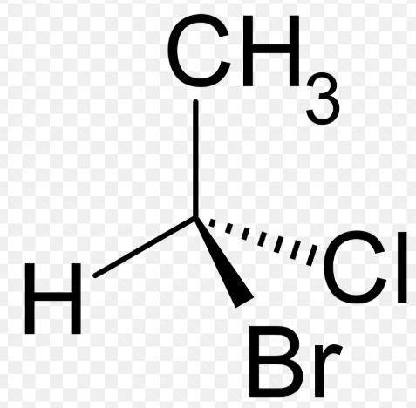 | (iii) | 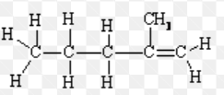
(iv) | 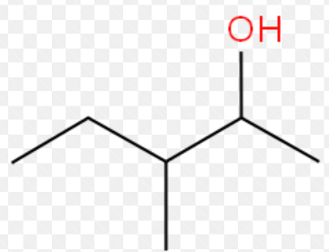 | (v) | 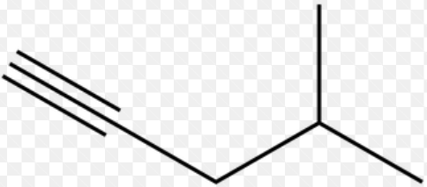 | (vi) | 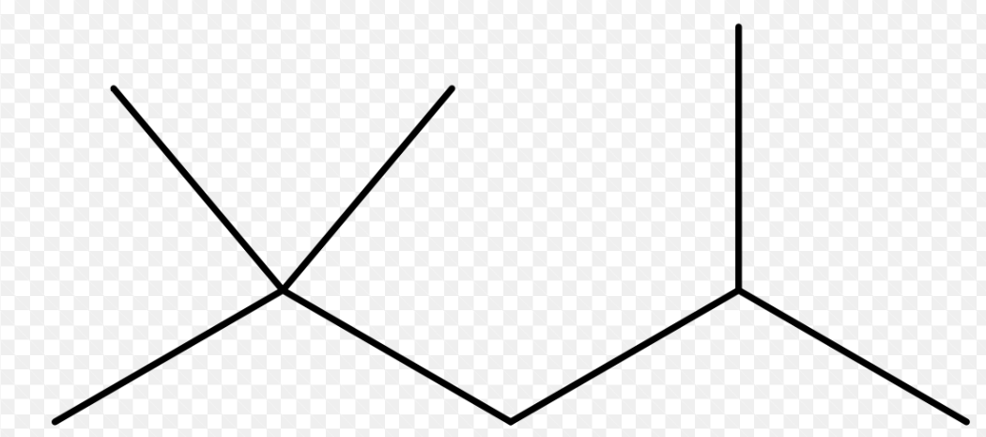
(vii) | 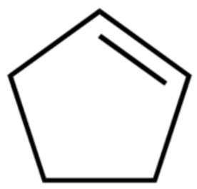 | (viii) |  | (ix) | 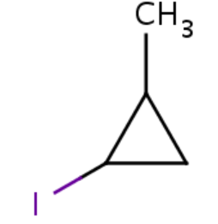
- Draw the structures of the following molecules:
(i) | ethan-1,2-diol | (ii) | 1,2-dibromopropane | (iii) | 2-methylpentan-3-ol
(iv) | 3-methylbutan-1-ol | (v) | 2-methylbut-1-ene | (vi) | propan-1,2,3-triol
(vii) | cyclobutanol | (viii) | 1,1-dichlorocyclopropane | (ix) | 4-methylcyclopentene

- Recognising Identical Organic Molecules

- Many organic compounds which appear to be different are in fact the same; they appear to be different because different notations are used, or because some of the bonds are simply rotated; note than all single bonds are able to rotate freely

Eg Butane, for example, can be represented in a number of ways:
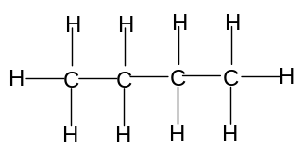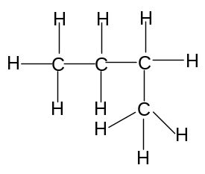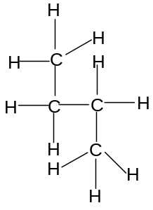

Eg 1-chloropropane can be represented in a number of ways:
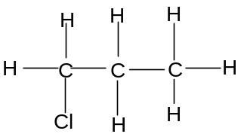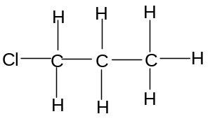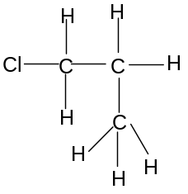

- All molecules which are identical must have the same name and all molecules with the same name must be identical; non-identical molecules cannot have the same name and molecules with different names must be non-identical

- Homologous series

- Organic compounds with the same functional group, but a different number of carbon atoms, are said to belong to the same homologous series; every time a carbon atom is added to the chain, two hydrogen atoms are also added; a homologous series is a series of organic compounds which have the same functional group, but in which the formula of each successive member increases by -CH₂-

Eg Homologous series of unbranched alkanes:
CH₄, CH₃CH₃, CH₃CH₂CH₃, CH₃CH₂CH₂CH₃, CH₃(CH₂)₃CH₃, CH₃(CH₂)₄CH₃ etc

Eg Homologous series of alcohols:
CH₃OH, CH₃CH₂OH, CH₃CH₂CH₂OH etc

- As a homologous series is ascended, the size of the molecule increases; therefore the Van der Waal’s forces between the molecules become stronger and the boiling point increases
- Eg propan-1-ol has a higher boiling point than ethanol
- Eg butane has a higher boiling point than propane

- Members of the same homologous series tend to have similar chemical properties; the chemical properties of an organic molecule depend mainly on the functional group; the functional group can also alter the physical properties of the molecule – for example ethanol, ethene and ethane will have different physical and chemical properties

Lesson 5 – How can we predict, recognise and classify isomers?

- Isomerism

- Isomers are molecules which have the same molecular formula but different structures

Summary Activity 5.1: What are isomers?
- How many different molecules can you draw with the molecular formula C₃H₇Cl? Can you name them? How are their structures different?
- How many different molecules can you draw with the molecular formula C₄H₈? Can you name them? How are their structures different?

- Isomerism can be classified either as structural isomerism or stereoisomerism

- Structural Isomerism

- Structural isomers are molecules which have the same molecular formula but a different arrangement of covalent bonds
The different arrangement of covalent bonds can result from:
- The functional group being in different positions (positional isomerism)
- A different arrangement of the carbon skeleton (chain isomerism)
- A different functional group (functional isomerism)

- Positional isomers are molecules with the same molecular formula and the same carbon skeleton but which have the functional group on different positions in the molecule
- alkanes do not show positional isomerism as they have no functional group
- alkenes with four or more carbon atoms show positional isomerism:
Eg but-1-ene and but-2-ene are positional isomers
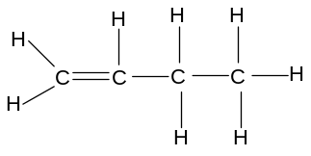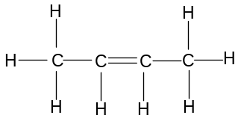
but-1-ene but-2-ene
C=C between C₁ and C₂ C=C between C₂ and C₃
- halogenoalkanes and alcohols with three or more carbon atoms show positional isomerism:
Eg 1-chloromethylpropane and 2-chloromethylpropane are positional isomers
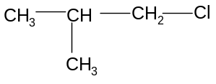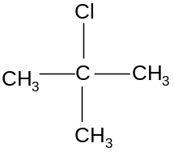
1-chloromethylpropane 2-chloromethylpropane
Cl on C₁ Cl on C₂

- Chain isomers are molecules with the same molecular formula and the same functional group but a different arrangement of carbon atoms (ie a different carbon skeleton)

- Carbon skeletons containing up to three carbon atoms can only be arranged in one way – i.e. a straight chain with no branching:

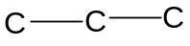

- Carbon skeletons containing four carbon atoms can be arranged in two ways:
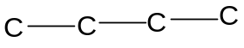 or 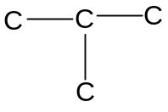
- Carbon skeletons containing five carbon atoms can be arranged in three ways:
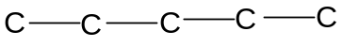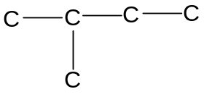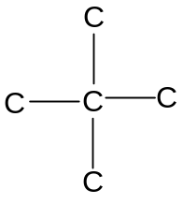

- All molecules containing four or more carbon atoms can thus show chain isomerism:
Eg butane and methylpropane are chain isomers:
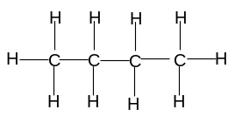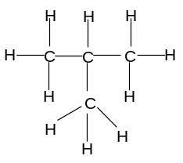
butane methylpropane
(unbranched) (methyl branch)

Eg pent-1-ene and 2-methylbut-1-ene are chain isomers:
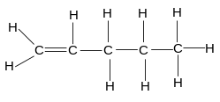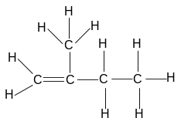
pent-1-ene 2-methylbut-1-ene
(unbranched) (methyl branch on C₂)

Eg 1-chloropentane and 1-chlorodimethylpropane are chain isomers:
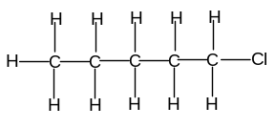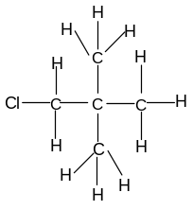
1-chloropentane 1-chlorodimethylpropane
(unbranched) (2 methyl branches)

- Functional isomers are molecules with the same molecular formula but different functional groups
This is most commonly found when one of the molecules is alicyclic and the other is aliphatic:
- alicyclic alkanes have the general formula C_{n}H_{2n}
- aliphatic alkenes also have the same general formula C_{n}H_{2n}
A cycloalkane and an alkene with the same number of carbon atoms will therefore be functional isomers of each other:
Eg cyclobutane and but-1-ene
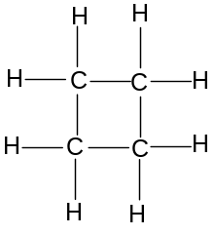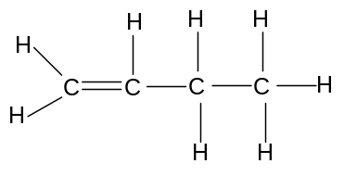
Cyclobutane but-1-ene
(no C=C bond) (C=C bond)

- Isomers have slightly different melting and boiling points
- molecules with no branching tend to have higher boiling points than isomers with more branching; this is because they have a higher surface area, so they pack together better and so the van der Waal’s forces are stronger
Eg isomers of pentane, C₅H₁₂:

Isomer | Structure | Boiling point/ºC
Pentane | 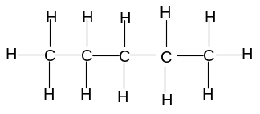 | 36
Methylbutane | 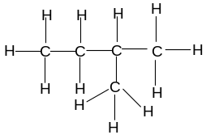 | 28
dimethylpropane | 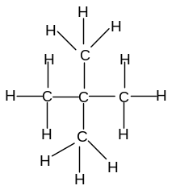 | 10

Test your knowledge 5.2: Recognising structural isomerism
- Draw and name two different molecules with the molecular formula C₂H₄Cl₂; state the type of isomerism occurring
- (i) show the structure of pent-1-ene
(ii) draw and name a positional isomer of pent-1-ene
(iii) draw and name a chain isomer of pent-1-ene
(iv) draw and name a functional isomer of pent-1-ene
- How many different alcohols are there with the molecular formula C₄H₁₀O? Draw and name them.
- State, with a reason, which of butane and methylpropane is likely to have the higher boiling point

Extension 5.3: Further structural isomerism
- Draw and name all of the alkenes with the molecular formula C₅H₁₀
- Draw and name all of the alcohols with the molecular formula C₅H₁₂O

Lesson 6 – What are stereoisomers?

- Stereoisomerism

- It is possible for two molecules to contain the same atoms bonded to each other but to be different from each other due to a different spatial arrangement; this is known as stereoisomerism; the only type of stereoisomerism required for this course is geometrical isomerism

- Stereoisomers are molecules with the same structural formula but a different spatial arrangement of atoms

- To understand geometrical isomerism, it is first necessary to understand more about the difference between single and double covalent bonds:
- Covalent bonds are formed when atomic orbitals on different atoms (usually each containing one electron) overlap, so that both electrons occupy the same region of space
- In single bonds, the orbitals overlap head-on to create a bond directly in between the nuclei of the two atoms:
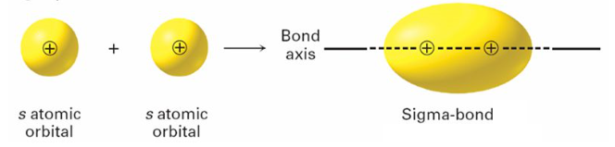(www.slideplayer.com)
This is known as a σ-bond; all single covalent bonds are σ-bonds
- In double bonds, the orbitals cannot overlap in the same way because the space directly in between the atoms is already occupied by the first covalent bond; instead, two p-orbitals overlap side-on to create a shared space above and below the σ-bond:
 (www.wikipedia.org)
This is known as a π-bond; all double covalent bonds consist of one σ-bond and one π-bond:
Eg orbital structure of ethene showing σ-bond and one π-bond:
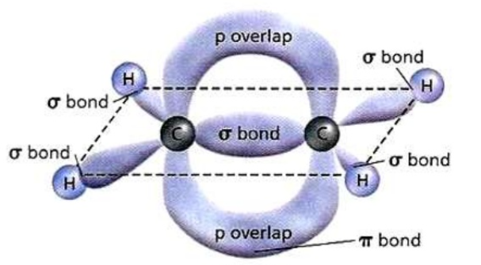(www.slideshare.net)

- Since π-orbitals overlap in two places, it is not possible to rotate a π-bond about its axis without breaking the bond; there is thus restricted rotation about the double bond

 Activity 6.1: Why can single bonds rotate and why can double bonds not rotate?
- Take two pieces of scrap paper; draw a small dot in the middle of each; then force a sharp pencil through both dots so the pencil passes through both sheets of paper; place the pieces of paper around 10 cm apart, still connected by the pencil; can you rotate one piece of paper without rotating the other one?
- Take two more pieces of scrap paper; draw two dots on each piece of paper, around 5 cm apart; then force a sharp pencil through one dot on each piece of paper so that the pencil passes through both sheets of paper; then force another sharp pencil through the second dot on each piece of paper; place the pieces of paper around 10 cm apart, still connected by two pencils; can you rotate one piece of paper without rotating the other one?

- Geometrical isomers are stereoisomers with different spatial orientations around the carbon-carbon double bond - it is caused by the restricted rotation about a carbon-carbon double bond, and it arises when the carbon atoms on both sides of the bond are attached two different groups:

Eg but-2-ene has a C=C double bond; the left-hand carbon is attached to two different groups (CH₃ and H) and the right-hand carbon is also attached to two different groups (CH₃ and H); the two CH₃ groups can either be adjacent to each other or opposite each other:

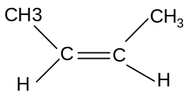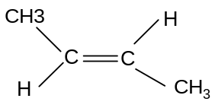
CH₃ groups adjacent CH₃ groups opposite
cis but-2-ene trans but-2-ene

These two isomers cannot be interconverted without breaking the π-bond; they have the same structural formula but different spatial orientations and are therefore stereoisomers; if the groups on the left hand side are the same as those on the right hand side, the molecule can be named “cis” if the same groups are adjacent, or “trans” if the same groups are opposite

Note that molecules which show geometrical isomerism always have two specific structural features:
- there is a carbon-carbon double bond
- both the carbon atoms are attached to two different groups

- Geometrical isomers should always be drawn using crab notation; crab notation shows the C=C bond as a planar centre with the 4 groups shown as follows:
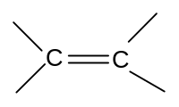
Using crab notation, it is easy to predict whether geometrical isomerism will exist in molecules:

Ethene | 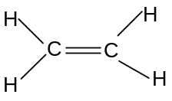 | No geometrical isomerism
Propene | 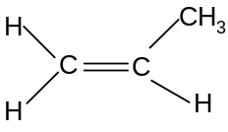 | No geometrical isomerism
But-1-ene | 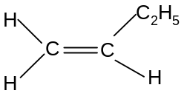 | No geometrical isomerism
But-2-ene | 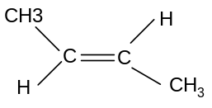 | Geometrical isomerism | cis but-2-ene trans but-2-ene
Methylpropene | 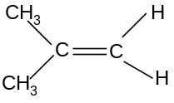 | No geometrical isomerism
Pent-1-ene | 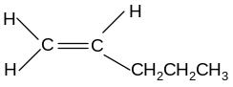 | No geometrical isomerism
Pent-2-ene | 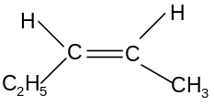 | Geometrical isomerism | 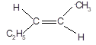  Trans pent-2-ene cis pent-2-ene
2-methylbut-1-ene | 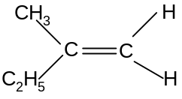 | No geometrical isomerism
2-methylbut-2-ene | 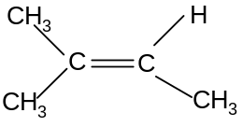 | No geometrical isomerism

Test your knowledge 6.2: Geometrical isomerism
- Molecules A, B, C, D, E and F are all isomers with the molecular formula C₅H₁₀. A and B are alicyclic. C is a branched alkene. D is an unbranched alkene. E and F are geometrical isomers of each other. Suggest names for all six molecules.
- Draw and name the two geometrical isomers of 1,2-dichloroethene. Explain why 1,1-dichloroethene does not show geometrical isomerism. Explain why 1,2-dichloroethane does not show geometrical isomerism

Lesson 7 – What is crude oil and why is it useful?

c) Crude Oil

- The vast majority of carbon-containing compounds used in the world have been made from crude oil; crude oil is also known as petroleum; it is found naturally underground, where it has formed from plant and animal matter over millions of years

- Crude oil is a mixture of alkanes, most of which are unbranched and contain 20+ carbon atoms; each of the hydrocarbons present in crude oil has a slightly different use; mixed together, they are of no use at all; it is necessary, therefore, to separate them before they can be used productively; crude oil is separated into its different components by a process called fractional distillation

- The products of fractional distillation are often converted into other, even more useful hydrocarbons by a process called cracking

- The discovery of crude oil and the development of techniques allowing it to be converted into fuels and other useful products (known as petrochemicals) is considered to be one of the major driving forces behind industrialisation

Summary Activity 7.1: Why do different hydrocarbons have different boiling points?
- What type of forces exist in between all molecules?
- How and why do these forces change as the molecules get larger?
- How and why do boiling points change as you ascend the homologous series of alkanes (ie from methane to ethane to propane etc)?
- Why do branched alkanes have lower boiling points than unbranched alkanes with the same number of carbon atoms?

- Fractional distillation

- The different hydrocarbons in crude oil have different boiling points; this is because the chain length varies; the longer the chain length, the stronger the Van der Waal’s forces and the higher the boiling point; the difference in boiling points of the different hydrocarbons in crude oil is used to separate them from each other

- The crude oil is passed into a tall tower called a fractionating column:
- this is very hot near the base but much cooler near the top
- when the crude oil is passed into the tower, near the bottom, most of the mixture boils and the gaseous molecules start to rise up the tower
- as they rise up the tower, they start to cool down and will gradually condense back into liquid form; they are then tapped off
- the larger hydrocarbons, with higher boiling points, will condense first and be tapped off near the base of the column
- the smaller hydrocarbons, with smaller boiling points, will condense later and be tapped off near the top of the column
- thus the separation is achieved
- note that the process involves breaking intermolecular forces only; the molecules themselves are unaffected by this process

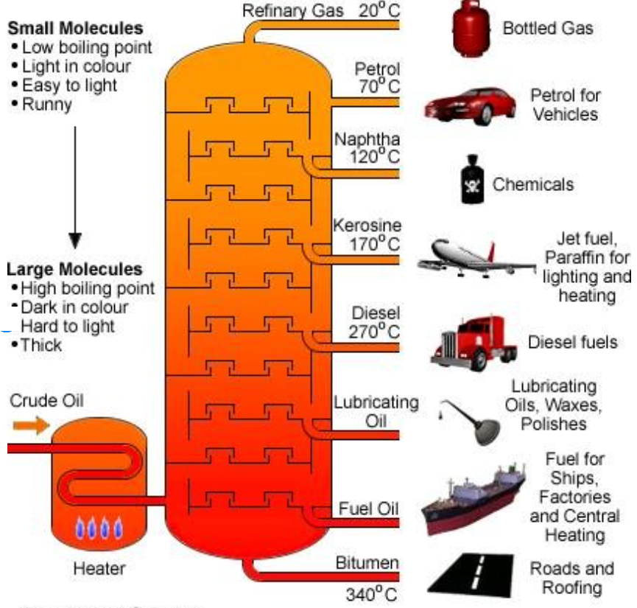
www.researchgate.net

- This process does not actually separate the crude oil mixture into pure hydrocarbon components, but into mixtures called fractions; fractions are mixtures of hydrocarbons with similar boiling points; in many cases these fractions can be used directly, but sometimes further separation is required into purer components; the most important fractions and their main uses are summarised as follows:

Fractions from crude oil

Name of fraction | Boiling range  / ºC | Number of hydrocarbons | Uses
Liquefied petroleum gas | Less than 25  Above 450 | 1 – 4  More than 50 | Gas for camping/ cooking
Petrol or gasoline | Less than 25  Above 450 | 1 – 4  More than 50 | Fuel for cars etc
Naphtha | Less than 25  Above 450 | 1 – 4  More than 50 | Petrochemicals
Kerosine or paraffin | Less than 25  Above 450 | 1 – 4  More than 50 | Plane fuel, petrochemicals
Diesel or gas oil | Less than 25  Above 450 | 1 – 4  More than 50 | lorry, central heating fuel
Mineral/lubricating oil | Less than 25  Above 450 | 1 – 4  More than 50 | Lubrication, petrochemicals
Fuel oil | Less than 25  Above 450 | 1 – 4  More than 50 | Ship fuel, power stations
Wax and grease | Less than 25  Above 450 | 1 – 4  More than 50 | Candles, grease, polish
Bitumen or tar | Less than 25  Above 450 | 1 – 4  More than 50 | Road surfaces, roofing

- The term petrochemical means a useful chemical such as a solvent or paint, which is derived from crude oil

- Cracking

- Some of the fractions from crude oil are produced in greater quantities than needed, whilst others are not produced in sufficient quantities; the table below gives an example of the difference between the supply and demand of some important fractions:

Supply and demand for fractions

Fraction | Approximate supply/% | Approximate demand/%
Liquefied petroleum gases | 2 | 4
Petrol and naphtha | 16 | 27
Kerosine | 13 | 8
Gas oil | 19 | 23
Fuel oil and bitumen | 50 | 38

- This disparity can be corrected by breaking up some larger hydrocarbons in fuel oil into the smaller ones found in gas oil, or by breaking up some hydrocarbons in kerosene into the smaller ones found in petrol, naphtha or the liquefied petroleum gases; in other words the larger fractions (for which supply exceeds demand) can be broken up into smaller fractions (for which demand exceeds supply); the process by which this is carried out is called cracking

- Cracking has the added advantage of producing other useful hydrocarbons not naturally present in crude oil, such as alkenes (widely used as petrochemicals), cycloalkanes and branched alkanes (widely used in motor fuels); cracking is therefore important for two reasons:
- it converts low-demand fractions into higher demand fractions
- it makes other useful hydrocarbons not naturally found in crude oil

- Cracking involves the breaking of C-C bonds to form smaller molecules; C-C bonds are weaker than C-H bonds and so break more easily when heated; he conditions required for cracking are a high temperature and a catalyst

Eg C₈H₁₈ → C₆H₁₄ + C₂H₄
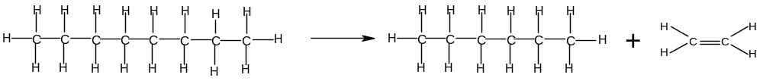

Eg C₆H₁₄ → C₃H₈ + C₃H₆
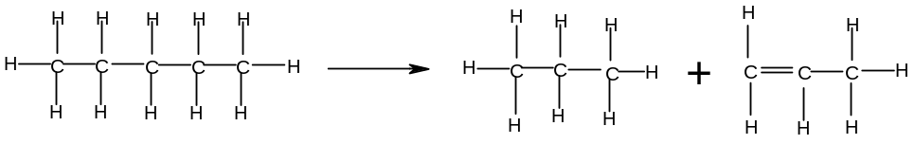

Eg C₁₂H₂₆ → C₈H₁₈ + 2C₂H₄

- Cracking always produces one shorter alkane molecule and at least one alkene
- if there are two products, one will be an alkane and the other will be an alkene
- if there are three products, one will be an alkane and two will be alkenes
- if there are four products, one will be an alkane and three will be alkenes etc

- Reforming

- Cracking produces shorter, more useful alkanes, but most of the products of cracking are aliphatic unbranched alkanes or alkenes; alicyclic alkanes tend to make better fuels, and so it is commercially useful to convert unbranched alkanes into alicyclic alkanes; this is carried out by a process called reforming:
Eg 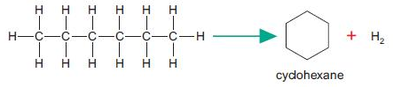

- Reforming also produces hydrogen gas, which can be used to make ammonia and various other important petrochemicals

Test your knowledge 7.2: Processing crude oil
- Crude oil is separated into its fractions by fractional distillation
- What are fractions?
- Explain how a fractionating column works in five key points
- Write down the names of five fractions, in order of increasing boiling point, and give a use for each
- Many of the fractions are then subjected to processes called cracking and reforming
- Write two different equations to show the cracking of decane ((C₁₀H₂₂) into two products
- Write an equation to show the cracking of dodecane (C₁₂H₂₆) into three different products
- Write an equation to show the reforming of hexane (C₆H₁₄)
- Explain why cracking and reforming are important

Lesson 8 – why are alkanes useful?

- Combustion of Alkanes

Summary Activity 8.1: Exothermic reactions
- What is an exothermic reaction?
- Why are exothermic reactions useful?
- Why do some exothermic reactions not take place until heat or a spark is applied?
- What do you understand by the terms “fuel” and “combustion”?

- Alkanes as fuels

- Many of the fractions produced from crude oil are used as fuels; these fractions include:

Fraction | Uses
Liquefied petroleum gases | Camping gas, cooking gas
Petrol | Fuel for cars, motorbikes and machines
Kerosine | Fuel for aeroplanes, lamps, ovens
Diesel | Fuel for lorries, and central heating systems
Fuel oil | Fuel for ships, power stations
Wax | Fuel for candles
- A fuel is a something that can be converted into useful energy; hydrocarbons, and especially alkanes, will react with oxygen in the air to give carbon dioxide and water; a reaction with oxygen is known as combustion; as alkanes are unreactive, the reaction usually needs heat or a spark to get going

Once started, these reactions are very exothermic, which means that heat energy is released; this heat energy can be used for direct heating (eg camping gas, central heating, candles); it can also be converted into mechanical energy (eg cars, lorries, ships), or electrical energy (eg power stations); the release of large quantities of heat energy during these combustion reactions results in their widespread use as fuels; typical examples of combustion reactions include:

Reaction | Enthalpy change/ kJmol⁻¹
CH₄ + 2O₂ → CO₂ + 2H₂O | -890
C₄H₁₀ + 6½O₂ → 4CO₂ + 5H₂O | -2877
C₈H₁₈+ 12½O₂ → 8CO₂ + 9H₂O | -5470

- Environmental problems associated with burning hydrocarbons

- carbon dioxide: although carbon dioxide is not poisonous and is naturally removed from the atmosphere by plants, the enormous quantities of hydrocarbons burned over the last century has caused carbon dioxide levels to rise significantly; carbon dioxide, along with various other compounds, prevents the earth’s heat from escaping into space and is resulting in an increase in the earth’s temperature; this is known as global warming; it also causes a significant change in the weather patterns on earth; this is known as climate change; gases which contribute towards global warming are known as greenhouse gases

- water vapour is also produced in large quantities as a result of combustion of hydrocarbons and is also a greenhouse gas

- carbon monoxide and carbon: the combustion of hydrocarbons to produce carbon dioxide and water is called complete combustion, and it requires a lot of oxygen; if oxygen is not present in sufficiently large quantities, carbon monoxide or carbon is produced instead of carbon dioxide; this is called incomplete combustion; examples of incomplete combustion reactions are:

C₄H₁₀ + 4½O₂ → 4CO + 5H₂O
C₄H₁₀ + 2½O₂ → 4C + 5H₂O
C₈H₁₈+ 10½O₂ → 8CO + 9H₂O
C₈H₁₈+ 8½O₂ → 8C + 9H₂O

The less oxygen that is available, the more likely it is that incomplete combustion will occur; this is a particular problem in internal combustion engines where the air supply is limited; incomplete combustion is a problem for three reasons:
- less energy is released by incomplete combustion than by complete combustion
- carbon monoxide is a pollutant – it is absorbed by the blood in place of oxygen, and hence reduces the ability of the blood to carry oxygen causing suffocation and eventually death
- carbon particles can cause breathing difficulties and cancer
It is therefore desirable to ensure that the air supply is as good as possible when burning hydrocarbon fuels. Occasionally incomplete combustion is desirable – such as with a Bunsen burner; closing the air hole produces a yellow flame (the yellow colour results from hot carbon particles) and this makes the flame more visible and causes a more gentle heat; usually, however, complete combustion is more desirable

- sulphur dioxide: most crude oil deposits contain sulphur as an impurity; oil refineries are increasingly treating the petrol fractions to lower the sulphur content, but some sulphur is still present in most hydrocarbon fuels; when the fuel is burned, the sulphur also burns, producing sulphur dioxide:
S(s) + O₂(g) → SO₂(g)
This gas dissolves in rainwater forming a very acidic solution, known as acid rain; this causes various problems, including erosion of buildings and statues, killing of plants and trees, and killing of fish through contamination of lakes

- oxides of nitrogen: most fuels are not burned in pure oxygen but in air, which contains 80% nitrogen; although nitrogen is not a reactive gas, the high temperatures and the spark in combustion engines cause some of the nitrogen to react with the oxygen to produce nitric oxide and nitrogen dioxide:
N₂(g) + O₂(g) → 2NO(g); 2NO(g) + O₂(g) → 2NO₂(g)
Nitrogen dioxide (NO₂) also dissolves in rainwater to form an acidic solution and contributes to the problem of acid rain

- unburned hydrocarbons: some of the hydrocarbon fuel is vaporised in the engine but escapes before it is burned; these unburned hydrocarbons cause various problems; they are toxic and can cause cancer if breathed in

- Quality of Petrol

- In most internal combustion engines, petrol is first compressed and then ignited; it is important that the fuel does not self-ignite before it has been fully compressed, as this has an adverse effect on the performance of the engine; the self-ignition of a fuel before it has been fully compressed is known as knocking

- Petrochemical companies are constantly trying to reduce knocking by changing the composition of the petrol; the ability of a fuel to resist knocking is known as its octane number

- Most traditional petrols are a mixture of heptane and 2,2,4-trimethylpentane:
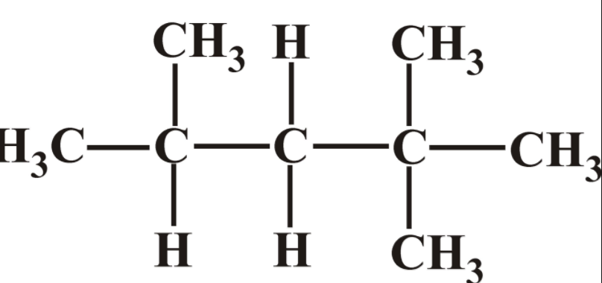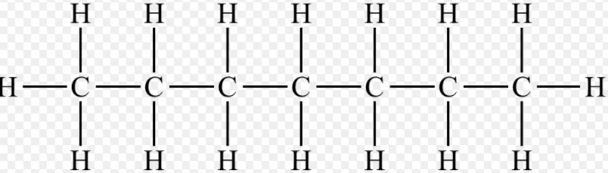
2,2,4-trimethylpentane heptane

- 2,2,4-trimethylpentane is resistant to knocking and is given an octane number of 100
- Heptane is susceptible to knocking and is given an octane number of 0
- all other fuels are allocated an octane number based on their resistance to knocking compared to 2,2,4-trimethylpentane and heptane
- a fuel with an octane number of 95, for example, is slightly less resistant to knocking than 2,2,4-trimethylpentane but much more resistant to knocking than heptane

Test your knowledge 8.2: Alkanes as fuels
- Write equations to show:
- the complete combustion of heptane (C₇H₁₆)
- the incomplete combustion of butane to make carbon monoxide
- the incomplete combustion of hexane (C₆H₁₄) to make carbon
- Identify three pollutants produced during the combustion of alkanes and explain how each pollutant is formed
- Explain the meaning of the term “octane number”

Lesson 9 – What are the typical reactions of alkanes, alkenes and alkynes?

- Preparation and Chemical Reactions of Alkanes, Haloalkanes, Alkenes and Alkynes

- Alkanes and Haloalkanes

- Methane is the main component in natural gas; most other alkanes are obtained industrially by the fractional distillation, cracking and reforming of crude oil

- Alkanes can be made in the laboratory by:
- the addition of hydrogen to an alkene; eg C₂H₄ + H₂ → C₂H₆
- the addition of hydrogen to a haloalkane; eg C₂H₅I + H₂ → C₂H₆ + HI

- Alkanes are mainly used as fuels for transport, domestic heating and electricity production

- Alkanes are also used as the starting point in the manufacture of a wide variety of organic products; the use of alkanes to manufacture other useful chemicals is known as the petrochemical industry

- The first step in the conversion of alkanes into other products is usually to convert alkanes into haloalkanes; one or more hydrogen atoms on the alkane are replaced by halogen atoms in presence of UV light:
Eg CH₄ + Cl₂ → CH₃Cl + HCl
CH₄ + 2Cl₂ → CH₂Cl₂ + 2HCl
C₃H₈ + Br₂ → C₃H₇Br + HBr
C₃H₈ + 2Br₂ → C₃H₆Br₂ + 2HBr
These reactions are called substitution reactions because they involve the replacement of a hydrogen by a halogen on the organic molecule
These reactions tend to produce a wide variety of different haloalkanes because:
- The number of halogen atoms replacing hydrogen atoms on each hydrocarbon can vary; reacting CH₄ and Cl₂ will result in a mixture of CH₃Cl, CH₂Cl₂, CHCl₃ or CCl₄
- The position of the halogen atoms on the carbon skeleton can vary; reacting C₃H₈ with Br₂ will result in a mixture of 1-bromopropane and 2-bromopropane, as well as a number of dibromoalkanes, tribromoalkanes etc

- Haloalkanes can be used to make a wide range of useful organic products, including plastics and pesticides; they can also be converted into a wide variety of other useful products, making them useful raw materials in the petrochemicals industry

- Haloalkanes in which all of the hydrogens have been replaced by halogen atoms (eg CCl₄, C₂F₆, C₂Cl₂F₄) are known as halons; they are used in refrigerators, air conditioning units and aerosols; however they are also known to damage the ozone layer (see Unit 13 – Chemistry in the World)

- Alkanes contain single bonds only and it is not possible to add additional atoms to alkanes without first removing another atom; for this reason alkanes are said to be saturated

- Alkenes

- Alkenes are usually prepared industrially by the cracking of alkanes

- Alkenes are usually prepared in the laboratory by the dehydration of alcohols; the alcohol is heated using concentrated sulphuric acid as the dehydrating agent:
Eg C₂H₅OH → H₂O + C₂H₄
C₂H₅CH₂OH → H₂O + C₃H₆
These reactions are called elimination reactions because they result in the loss of atoms from the organic molecule without replacement

- Alkenes can also be used as the starting point in the manufacture of a wide variety of petrochemicals

- The C=C double bond in alkenes can be easily broken and other atoms can be added to the carbon skeleton
- the reactions are known as addition reactions because atoms are added to the carbon skeleton but no atoms are removed
- the atoms being added must join the skeleton on the two carbon atoms where the double bond used to be
- this means that the products are much easier to predict and control – only one or two products will ever be formed
- with halogens (X₂), only one product is formed:
Eg C₃H₆ + Br₂ → C₃H₆Br₂ (1,2-dibromopropane only)
- with hydrogen halides (HX) and water, two products are formed if the alkene is unsymmetrical around the double bond (eg propene, but-1-ene); one product is formed if the alkene is symmetrical around the double bond (eg ethene, but-2-ene):
Eg CH₃CH=CHCH₃ + HCl → CH₃CHClCH₂CH₃ (2-chlorobutane only)
Eg CH₃CH=CHCH₃ + H₂O → CH₃CH(OH)CH₂CH₃ (butan-2-ol only)
Eg CH₂CH=CH₃ + HBr → CH₃CHBrCH₃ or CH₃CH₂CH₂Br (2-bromopropane or 1-bromopropane)

- Alkenes can also be converted to diols using KMnO₄ in alkaline solution; two -OH groups are added across the double bond to give a single organic product:
Eg C₃H₆ + [O] + H₂O → HOCH₂CH(OH)CH₃ (propan-1,2-diol only)
This reaction is known as hydroxyoxidation because oxygen is added in the form of two -OH (hydroxy) groups

- It is possible to test for alkenes in the laboratory; there are two common tests:
- Br₂/CCl₄; when bromine is shaken with an alkene in the presence of an inert organic solvent such as CCl₄, the mixture turns from orange to colourless (ie it decolorises); this is because the orange bromine is involved in an addition reaction with the alkene; when the bromine reacts, its colour disappears
Eg C₄H₈ + Br₂ → C₄H₈Br₂
- KMnO₄; when potassium manganate (VII) is shaken with an alkene in aqueous conditions, the mixture turns from purple to colourless (ie it decolorises); this is because the purple manganate (VII) ion is involved in a hydroxyoxidation reaction with the alkene; when the manganate (VII) ion reacts, its colour disappears
C₃H₆ + [O] + H₂O → HOCH₂CH(OH)CH₃
- Note that alkynes also give the same reactions, so these tests cannot distinguish between alkenes and alkynes

- Alkenes are said to be unsaturated as it is possible to add additional atoms to alkenes without first removing any
- Alkynes

- Ethyne is manufactured by adding water to calcium carbide (CaC₂):
CaC₂ + 2H₂O → C₂H₂ + Ca(OH)₂

- Ethyne is also a by-product of some cracking reactions

- The most important use of ethyne is to manufacture ethanal: C₂H₂ + H₂O → CH₃CHO; ethanal will be studied later in the course

- Ethyne is also used to make chloroethene, which is in turn used to make polychloroethene:
C₂H₂ + HCl → CH₂=CHCl
This is an example of an addition reaction

- Alkynes show many of the characteristic reactions of alkenes; alkynes decolorise both bromine (addition) and KMnO₄ (hydroxyoxidation); it is difficult to distinguish alkenes from alkynes in the laboratory

- Ethyne can be distinguished from alkenes and alkanes because it will give a yellow-white precipitate (of Ag₂C₂) when bubbled through an aqueous ammoniacal solution of AgNO₃(aq); this happens because ethyne is weakly acidic, dissociating very slightly in aqueous solution to form H⁺ ions, especially in the presence of an alkali such as ammonia:
C₂H₂ (aq)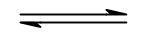2H⁺(aq) + C₂²⁻(aq)
The resulting carbide (C²⁻) ion will react with Ag⁺ ions to give a yellow-white precipitate of Ag₂C₂:
Ag⁺(aq) + C²⁻(aq) → Ag₂C₂(s)
Neither ethane nor ethene are acidic; they therefore do not give this reaction

- Like alkenes, alkynes are said to be unsaturated as it is possible to add additional atoms to alkenes without first removing any

Test your knowledge 9.1: Simple reactions of hydrocarbons
- Describe a simple laboratory preparation of each of ethane, ethene and ethyne
- Explain the difference between addition reactions, substitution reactions and elimination reactions and give one simple example of each in organic chemistry
- Describe a simple chemical test to distinguish between ethane and ethene
- Describe a simple chemical test to distinguish between ethene and ethyne
- Give the structure(s) of the organic product or products formed when:
- Ethane reacts with chlorine in the presence of UV light
- Propene reacts with hydrogen bromide
- But-1-ene reacts with KMnO₄
- Ethyne reacts with hydrogen chloride
State the type of reaction occurring in each case

Lesson 10 – What are aromatic compounds?

- Benzene and Aromatic Compounds

- Structure

- Benzene is a cyclic hydrocarbon containing six carbon atoms and six hydrogen atoms (C₆H₆); it was originally thought to contain alternate single and double bonds (cyclohex-1,3,5-triene) as follows:
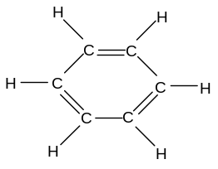
- It is usually represented as its skeletal formula:
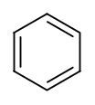
- This structure is often known as the Kekule structure of benzene; it is now known that this is not the correct structure of benzene, although the molecule is often drawn in this way
- If this structure were correct, the sides of the hexagon with double bonds would be shorter than the sides with single bonds; this is because C=C bonds are shorter than C-C bonds, as the extra π–orbital overlap brings the atoms closer together:
 |  |  | Bond | Length/nm
 |  |  | C-C | 0.154
 |  |  | C=C | 0.134
- Analysis of the molecule, however, shows that all bonds have a length of 0.142 nm, intermediate between single and double; it is therefore believed that that the structure did not in fact contain alternate single and double bonds but contained delocalized electrons in six overlapping orbitals:
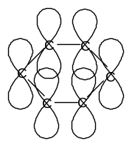
- The delocalized electrons can be represented as a circle within the hexagonal ring:
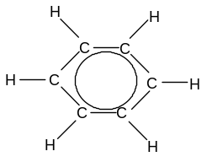
- Benzene is usually represented by its skeletal formula:
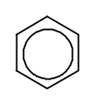
- All six C-C bonds have the same length, the angle between the bonds 120º and the molecule is planar
- This delocalisation of electrons is known as resonance

- Any molecule containing the benzene ring can be described as aromatic (as distinct from aliphatic or alicyclic)

- Stability and Reactions

- The delocalization (resonance) of the electrons in benzene makes the molecule more stable than expected for a molecule with three double bonds; as benzene contains carbon-carbon double bonds, it might be expected to behave like alkenes; i.e. react readily with bromine and hydrogen to undergo addition reactions, but this is not the case; benzene will not decolorise bromine water and will not readily undergo any other addition reactions

- Addition reactions break up the delocalized system and are therefore not favoured; benzene thus tends to undergo substitution, rather than addition reactions; in this respect the reactivity of benzene is more similar to alkanes than to alkenes

- In the presence of a catalyst such as AlCl₃ or FeBr₃, benzene can undergo a substitution reaction with a halogen: Eg C₆H₆ + Br₂ → C₆H₅Br + HBr

- In more extreme conditions (high pressure, high temperature and UV light), benzene can be persuaded to undergo an addition reaction with a halogen: Eg C₆H₆ + 3Cl₂ → C₆H₆Cl₆ or hydrogen: C₆H₆ + 3H₂ → C₆H₁₂

- Uses of benzene

- Benzene is used to make ethylbenzene, which is in turn used to make polystyrene.

- Benzene is also added to petrol to improve its octane number

- Benzene is used as the starting point in the manufacture of a variety of petrochemicals, including pharmaceutical products and dyes

Test your knowledge 10.1: Benzene
- Describe the structure and bonding in benzene
- Write an equation to show benzene reacting with chlorine:
- in an addition reaction
- in a substitution reaction
- Explain why benzene undergoes substitution reactions more readily than it undergoes addition reactions
- Give two uses of benzene
- Explain the meaning of the term “aromatic”

Lesson 11 – What have I learned about Organic Chemistry?

11.1 END-OF-TOPIC QUIZ

UNIT 7 – INTRODUCTION TO ORGANIC CHEMISTRY

- Draw the structure of: (i) a saturated branched aliphatic hydrocarbon; (ii) an unsaturated unbranched aliphatic hydrocarbon; (iii) a saturated unbranched alicyclic hydrocarbon; (iv) an aromatic hydrocarbon

- Show the structures of the following molecules: (i) methylbutane; (ii) pent-2-ene; (iii) 3-methylbutan-1-ol; (iv) 1,2-dibromopropane; (v) cyclobutanol

- Name the following molecules:
- 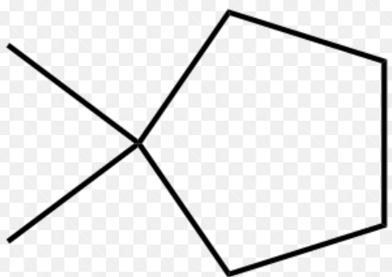; (ii) CH₃CH₂CH₂OH; (iii) (CH₃)₂C=CHCH₃; (iv)(CH₃)₃CBr; (v) 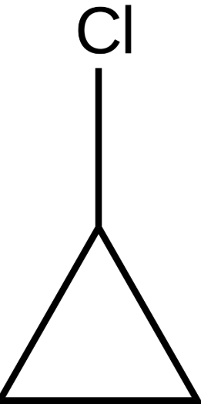

- Draw and name all the alcohols with the molecular formula C₃H₈O

- Draw two molecules with the molecular formula C₅H₁₀ which are:
(i) positional isomers; (ii) functional isomers; (iii) chain isomers; (iv) geometrical isomers

- Name the first three molecules in the homologous series of alkanes and state and explain their trend in boiling points

- Describe briefly how crude oil is separated into its fractions

- Write a possible equation to show the cracking of octane (C₈H₁₈)

- Write a possible equation to show the reforming of hexane (C₄H₁₄)

- Name three fractions produced from crude oil and state their main use

- Write an equation for: (i) the complete combustion of pentane; (ii) the incomplete combustion of methane

- Explain how sulphur dioxide is produced during combustion and explain why it is a pollutant

- Describe a simple test to distinguish cyclopentane from pent-1-ene

- Draw both products formed when pent-1-ene reacts with HBr

- Explain why benzene tends to undergo substitution rather than addition reactions

