2.1.1 Exercise 3 – ISOMERISM IN ALKANES
1. Draw the molecular, empirical, structural, skeletal and displayed formulae for hexane:
molecular | empirical | structural | skeletal | displayed

2. State the meaning of the terms:
Molecular formula

Empirical formula

Structural Formula

Skeletal Formula

Displayed Formula

3. Hexane is a saturated hydrocarbon and an aliphatic alkane
What is meant by the terms:
Saturated

Hydrocarbon

Aliphatic

Alkane

4. Hexane has four isomers.
a) What are isomers?
Isomers

b) Draw the skeletal formulae of the four isomers of hexane and name them:
Skeletal Formula | Name

5. What is the general formula for alkanes?
6. Name the following compounds:
A  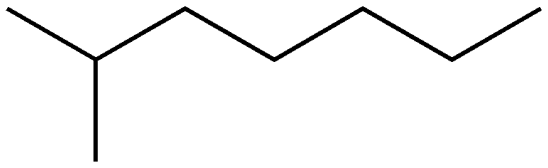  2-methylheptane | B  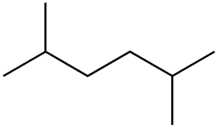 | C  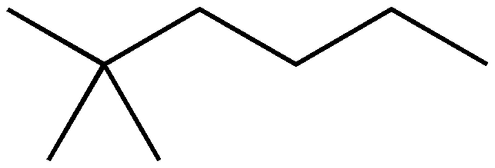
D  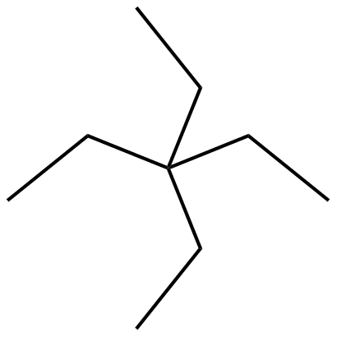 | E  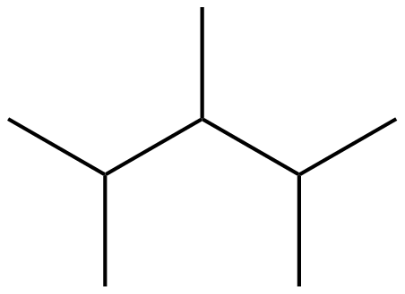 | F  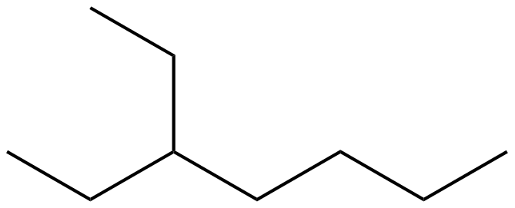
G  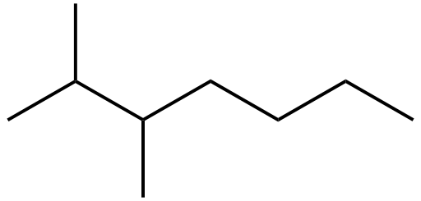 | H  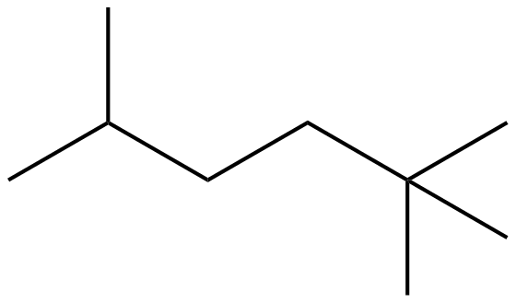 | I  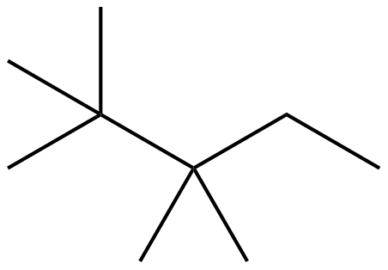

- Which three molecules are isomers of A?

- Draw the structural formula of E

- Draw the displayed formula of D

- What is the molecular formula of D?

- What is the empirical formula of C?

- Draw the skeletal formula of the unbranched isomer of I

- State which of A – I are aliphatic saturated hydrocarbons

