2.1.2 EXERCISE 1 - HYDROCARBONS FROM CRUDE OIL
a) fractional distillation
1. What is crude oil made of?

2. What is a ‘fraction’?

3. By what process is crude oil separated into its fractions?

4. Explain how this process works.

5. Explain why this process is necessary.

6. State and explain the trend in boiling points of the following molecules:
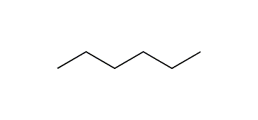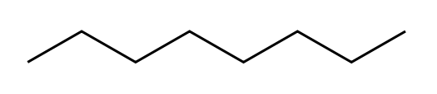

7. State and explain the trend in boiling points of the following molecules:
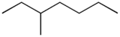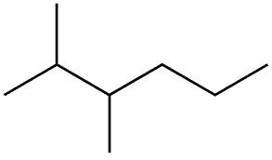

8. Hence explain why hydrocarbons of different chain lengths can appear in the same fraction.

9. State the main use of alkanes and state which types of alkane are most useful for this purpose.

10. State the main use of alkenes.

11. Hence give three reasons why the further refining of crude oil would increase its commercial value.
b) cracking
12. What is cracking?

13. Give two economic benefits of cracking.

14. Explain why cracking gives a large variety of different products.

15. What are the conditions required for cracking?

16. Write an equation for the cracking of C₁₄H₃₀ to give:
- two products only

- octane and two other products

- two molecules of propene and one other product

- one molecule of ethene, two molecules of propene and one other product

17. Cracking produces mainly unbranched alkanes. Explain why further refining of the products of cracking would increase their commercial value.

