UNIVERSITY OF SIERRA LEONE
CHEM 111
FOURAH BAY COLLEGE

FIRST EXAMINATION FOR THE DEGREE OF B. Sc. HONOURS

LEVEL I

FIRST SEMESTER EXAMINATION
APRIL 2018

PHYSICAL AND INORGANIC CHEMISTRY

TIME ALLOWED: 3 HOURS PLUS 15 MINUTES READING TIME

INSTRUCTION: THIS PAPER IS DIVIDED INTO THREE SECTIONS: A, B AND C. ANSWER ALL QUESTIONS IN SECTION A AND A TOTAL OF THREE (3) QUESTIONS FROM SECTIONS B AND C, WHICH MUST INCLUDE AT LEAST ONE QUESTION FROM EACH SECTION.

SECTION A (ANSWER ALL QUESTIONS)

SECTION B (ANSWER 1 OR 2 QUESTIONS)

SECTION C (ANSWER 1 OR 2 QUESTIONS)

The value of the molar gas constant R = 8.31 JK⁻¹mol⁻¹

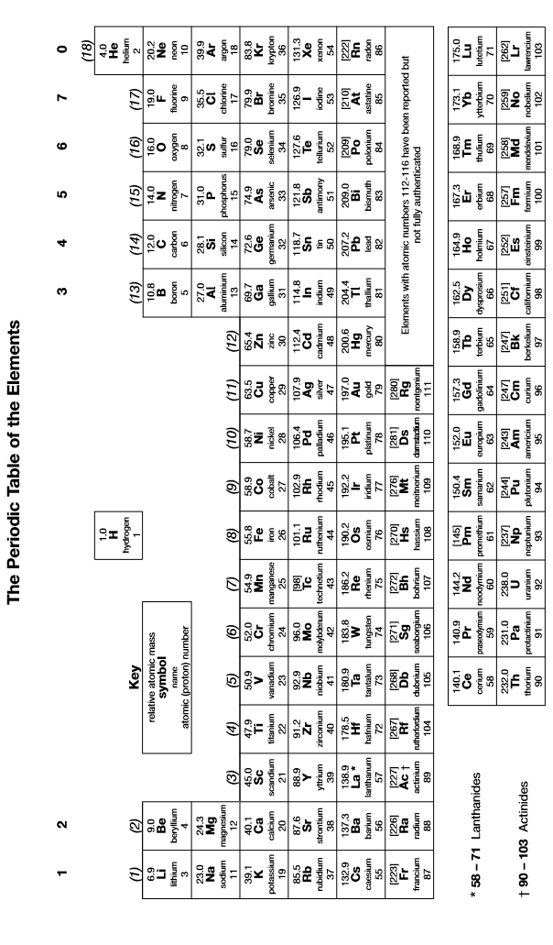

Section A
1. | Write the formulae of the following compounds:
 | (a) | copper (I) oxide
 | (b) | potassium manganate (VII)
 | (c) | calcium nitrate (V)
 | (d) | aluminium sulphide
 | (e) | sodium chlorate (V)  [5]
2. | Hydrogen peroxide can be prepared by the treatment of barium peroxide (BaO₂) with dilute sulphuric acid: BaO₂(s) + H₂SO₄(aq) BaSO₄(s) + H₂O₂(aq)  A student added 5.0 g of BaO₂ to 50 cm³ of 2.0 moldm⁻³ H₂SO₄. The total volume of the solution did not change.
 | (i) | Deduce which of the reactants is in excess and hence deduce the molarity of the H₂O₂ solution produced during this reaction.
 | (ii) | Deduce the percentage atom economy of this reaction for the production of H₂O₂.  [5]
3. | (a) | A hydrated salt was found to have the following mass composition: Ca 23.3%, S 18.6%, O 55.7% and H 2.3%. Deduce the empirical formula and suggest a possible unit formula for the compound.
 | (b) | When heated, this salt becomes anhydrous. If a 5.0 g sample of the salt is heated, calculate the mass of solid remaining after heating to constant mass.  [5]
4. | Potassium reacts vigorously with water according to the following equation:  2K(s) + 2H₂O(l) 2KOH(aq) + H₂(g)  A 2.5 g piece of potassium was dropped into a container containing 2 dm³ of water and allowed to react completely. The total volume of the solution did not change. Calculate:  - The molarity of the KOH solution produced  - The volume of hydrogen produced at 298 K and 100 kPa  [5]
5. | 2.35 g of sodium hydroxide was dissolved in water and the total volume of solution made up to 250 cm³. 25.0 cm³ of this solution was titrated against 0.20 moldm⁻³ HCl using a suitable indicator.
 | (a) |  | Calculate the expected volume of HCl required to neutralise the NaOH solution.
 | (b) |  | Identify the four measuring instruments likely to have been used in this experiment and calculate the percentage apparatus error for each measurement.
 | (c) |  | Hence calculate the total apparatus error for the experiment and hence suggest a suitable number of significant figures for your answer.  [5]

6. | One method for the manufacture of nitric acid involved the combustion of ammonia in the presence of a catalyst as follows:  4NH₃(g) + 5O₂(g)4NO(g) + 6H₂O (g)  It is an exothermic reaction.  State and explain the effect on the percentage yield of NO of
 | (a) | Increasing the temperature
 | (b) | Increasing the pressure
 | (c) | Removing the catalyst  [5]
7. | A chemical reaction between E and F reaches equilibrium as follows:  E (g) + 2F(g) 2G(g) ΔH = –50 kJ mol^{–1}  A 2.0 mol sample of E was heated in a sealed container with a 1.0 mol sample of F.  Equilibrium was established at a given temperature and the equilibrium mixture formed contained 0.80 mol of G.  Deduce the value of K_{c} for this reaction, giving suitable units  [5]
8. | (a) | Calculate the molarity of a solution of KOH which has a pH of 13.74
 | (b) | Calculate the pH of a solution of 0.05 moldm⁻³ CH₃COOH (K_{a} = 1.8 x 10⁻⁵ moldm⁻³)  [5]
9. | (a) | Calculate the value of K_{sp} for PbCl₂ given that its solubility in water is 0.011 moldm⁻³.
 | (b) | The K_{sp} of silver bromide (AgBr) is 7.7 x 10⁻¹³ mol²dm⁻⁶. Deduce the molar solubility of silver bromide.  [5]
10. | (a) | Sketch a curve to show how the pH changes when a solution of 0.05 moldm⁻³ NH₃ is added gradually to 25 cm³ of 0.10 moldm⁻³ HCl.
 | (b) | Suggest, with a reason, a suitable indicator for this titration.  [5]

Section B
1. | This question is about different types of titrations.
 | (a) | Succinic acid (H₂X) is a diprotic acid, which reacts with sodium hydroxide as follows:  H₂X + 2NaOH Na₂X + 2H₂O  2.00 g of succinic acid were dissolved in water and the volume was made up to 250 cm³ in a volumetric flask. This solution was placed in a burette and 18.4 cm³ was required to neutralise 25 cm³ of 0.1 moldm⁻³ NaOH.  Deduce the molar mass of succinic acid.  [5]
 | (b) | 1.12 g of a metal chloride MCl₂ was dissolved in water and the volume was made up to 250 cm³ in a volumetric flask. 25.0 cm³ of this solution was titrated against 0.050 moldm⁻³ AgNO₃ and 21.6 cm³ of the AgNO₃ solution was required to react completely with the MCl₂ solution.  - Write an ionic equation to show MCl₂ dissolving in water  - Write an ionic equation for the reaction taking place during the titration  - Deduce the identity of the metal M  [7]
 | (c) | A solution of industrial hydrogen peroxide of volume 5 cm³ was diluted to 250 cm³ in a volumetric flask. A 25.0 cm³ portion of the diluted solution was acidified and titrated against 0.0150 moldm⁻³ potassium permanganate solution, and 19.7 cm³ were required.  Hydrogen peroxide is oxidized according to the following equation:  H₂O₂(aq) 2H⁺(aq) + O₂(g) + 2e  - Write an ionic equation for the reaction taking place during the titration  - Deduce the molarity of the industrial hydrogen peroxide solution before dilution  [6]
 | (d) | The National Bank of Sierra Leone is planning to introduce a Le 1,000 coin, made from a mixture of copper and nickel.  One such coin weighing 1.72 g was completely dissolved in concentrated nitric acid until all of the copper in the coin had been oxidised to copper (II) ions. The excess nitric acid was then neutralised and the volume made up to 250 cm³ in a volumetric flask. 25 cm³ portions of this solution were then added to a conical flask and an excess of potassium iodide was then added. Cu²⁺ ions react with iodide ions as follows:  2Cu²⁺ + 4I⁻ 2CuI + I₂  The resulting solution was titrated against 0.1 moldm⁻³ Na₂S₂O₃, and 15.7 cm³ was required.  - Write an equation for the reaction taking place during the titration  - Determine the percentage of copper in the coin  [6]
 | (e) | Estimate the total percentage apparatus error resulting from the titration in part (a) of this question.  [3]  max 25 marks

2. | This question is about hydrochloric acid, which is a strong acid commonly used in the laboratory as well as in industry.
 | (a) | Industrial concentrated hydrochloric acid contains 36% HCl by mass and has a density of 1.18 gcm⁻³. It needs to be diluted before it is safe to use in the laboratory.
 |  | (i) | Calculate the mass of 10.0 cm³ of concentrated hydrochloric acid.
 |  | (ii) | Hence calculate the mass of pure HCl in 10.0 cm³ of concentrated hydrochloric acid.
 |  | (iii) | Hence calculate the molarity of concentrated hydrochloric acid.
 |  | (iv) | Hence calculate the pH of concentrated hydrochloric acid.  [5]
 | (b) | Calculate the mass of concentrated hydrochloric acid which should be diluted to make 250 cm³ of a 0.10 moldm⁻³ solution of HCl.  [4]
 | (c) | (i) | What is the pH of 0.050 moldm⁻³ HCl?
 |  | (ii) | What volume of water should be added to 25 cm³ of 0.050 moldm⁻³ HCl to increase this pH to 1.50?
 |  | (iii) | What will be the final pH of a solution when 10.0 cm³ of 0.075 moldm⁻³ NaOH is added to 25 cm³ of 0.050 moldm⁻³ HCl?  [9]
 | (d) | Concentrated HCl is a reducing agent; it can be oxidised to chlorine gas and it can reduce PbO₂ to Pb²⁺ ions.
 |  | (i) | Write the half-equation for the oxidation of hydrochloric acid to chlorine gas
 |  | (ii) | Write the half-equation for the reduction of PbO₂ to Pb²⁺
 |  | (iii) | Hence write an ionic equation for the reaction between PbO₂ and HCl  [3]
 | (e) | Write equations to show how dilute hydrochloric acid reacts with:  (ionic equations are always acceptable)
 |  | (i) | Ammonia
 |  | (ii) | calcium carbonate
 |  | (iii) | sodium hydrogencarbonate
 |  | (iv) | magnesium hydroxide
 |  | (v) | aqueous silver nitrate  [6]  max 25 marks

3. | (a) | (i) | Outline briefly the process of scientific enquiry, and hence explain the difference between the terms “hypothesis”, “law” and “theory”.
 |  | (ii) | Explain the difference between a theory and a theorem, and the difference between induction and deduction.
 |  | (iii) | What is meant by the term “serendipity”?  [9]
 | (b) | (i) | What is the difference between the terms “molarity” and “molality”?
 |  | (ii) | When 90.00 g of glucose (C₆H₁₂O₆) are dissolved in water and the volume made up to 250.0 cm³ using a volumetric flask, the resulting solution was found to have a density of 1.131 gdm⁻³. Calculate the molarity and the molality of the glucose solution.
 |  | (iii) | When 22.50 g of glucose was dissolved in 100.0 cm³ of water, the total volume of the solution increased to 108.3 cm³. Calculate the molarity and the molality of the glucose solution, assuming that the density of water is 0.997 gcm⁻³.  [8]
 | (c) | Three different reactions of sulphuric acid are described below:
 |  | (i) | Sulphuric acid was dropped onto a solution containing bromide ions. The resulting mixture was found to contain both sulphur dioxide and bromine.
 |  | (ii) | Sulphuric acid was added gradually to a solution of barium chloride.
 |  | (iii) | Some copper (II) oxide powder was added to sulphuric acid.
In each case, state and explain the type of reaction occurring and write an equation for the reaction taking place. Ionic equations are acceptable.
[9]
max 25 marks

Section C
1. | (a) | What is meant by the term “buffer solution”?  [2]
 | (b) | Calculate the pH of the buffer solution formed when 10 cm³ of 0.10 moldm⁻³ NaOH is added to 25 cm³ of 0.080 moldm⁻³ C₂H₅COOH (K_{a} of C₂H₅COOH is 1.3 x 10⁻⁵ moldm⁻³).  [6]
 | (c) | Explain, with the aid of equations, how this buffer solution works.  [5]
 | (d) | Ammonia (NH₃) is a weak base with a K_{b} of 1.7 x 10⁻⁵ moldm⁻³.
 |  | (i) | Calculate the pH of 0.050 moldm⁻³ NH₃.
 |  | (ii) | Suggest, with a reason, a substance which could be added to a solution of ammonia to make a buffer solution.
 |  | (iii) | Calculate the quantity of this substance (in moles) which should be added to 100 cm³ of 0.10 moldm⁻³ NH₃ to make a buffer solution with a pH of 9.5.  [12]  Total 25 marks
2. | (a) | Explain the meaning of the terms “Bronsted-Lowry acid”, “Bronsted-Lowry base” and “acid-base conjugate pair”.  [3]
 | (b) | Write an equation for the reversible reaction between HCOOH and H₂O.  Use the equation to Identify:
 |  | (i) | The Bronsted-Lowry acid and base in the forward reaction;
 |  | (ii) | The Bronsted-Lowry acid and base in the reverse reaction;
 |  | (iii) | The acid-base conjugate pairs in the reaction  [7]
 | (c) | The ionic product of water at 25 ºC is 1.00 x 10⁻¹⁴ mol²dm⁻⁶, but at 50 ºC it is 5.48 x 10⁻¹⁴ mol²dm⁻⁶.
 |  | (i) | What does this information tell you about the enthalpy change for the auto-ionization of water?
 |  | (ii) | Calculate the pH of pure water at 25 ºC and at 50 ºC  [6]
 | (d) | Methylamine (CH₃NH₂) is a weak base with a K_{b} of 4.4 x 10⁻⁴ moldm⁻³. Ethanoic acid (CH₃COOH) is a weak acid with a K_{a} of 1.8 x 10⁻⁴ moldm⁻³.
 |  | (i) | Explain the meaning of the term “salt hydrolysis”.
 |  | (ii) | Deduce the pH of 0.050 moldm⁻³ CH₃NH₃Cl
 |  | (iii) | Deduce the pH of 0.050 moldm⁻³ CH₃COONa
 |  | (iv) | Deduce the pH of 0.10 moldm⁻³ KCl  [9]  Total 25 marks

3. | (a) | (i) | When a mixture of 0.345 mol of PCl₃ and 0.268 mol of Cl₂ was heated in a vessel of fixed volume to a temperature of 400 K, the following reaction reached equilibrium.  PCl₃(g) + Cl₂(g) PCl₅(g) ΔH = –93 kJ mol^{–1}  At equilibrium, 0.166 mol of PCl₅ had been formed and the total pressure was 225 kPa.  Deduce the value of K_{p}
 |  | (ii) | Derive an expression to show the relationship between K_{c} and K_{p}, and hence calculate the value of K_{c} for the above reaction.  [9]
 | (b) | (i) | Consider the following equilibrium: NH₄CO₂NH₂(s) 2NH₃(g) + CO₂(g).  A solid sample of NH₄CO₂NH₂ was allowed to decompose to equilibrium at 400 K in an evacuated container. The total gas pressure was found to be 36.3 kPa. Calculate K_{p} for the reaction.
 |  | (ii) | Hence calculate values of K_{p} for the following reactions:  - 2NH₃(g) + CO₂(g)NH₄CO₂NH₂(s)  - ½NH₄CO₂NH₂(s) NH₃(g) + ½CO₂(g)  [9]
 | (c) | During the industrial production of ammonia, nitrogen and hydrogen react according to the following equation: N₂(g) + 3H₂(g) 2NH₃(g), ΔH = -92 kJmol⁻¹
 |  | (i) | Describe the conditions of temperature and pressure which would maximise the yield of ammonia in the above reaction.
 |  | (ii) | Suggest reasons why industrialists may not choose to use the conditions which give the best yield of ammonia.  [7]  Total 25 marks`

