Section A

A1. | (a) | M1: H and/or Br can join either C on C=C
 | (b) | M2: curly arrow from C=C to H in H-Br, dipole on H-Br (δ⁺- δ⁻), curly arrow from H-Br to Br (any 2)  M3: carbocation: CH₃CH⁺CH₃  M4: Br⁻, curly arrow from lone pair on Br to C⁺, CH₃CHBrCH₃ (any 2)
 | (c) | CH₃CH₂CH₂Br  [5]
A2. | (a) | M1: curly arrow from C-I to I  M2: carbocation: CH₃CH₂CH⁺CH₃  M3: curly arrow from lone pair on C in CN⁻ to C⁺ in C-I
 | (b) | M4: S = substitution, CN replaces I, N = nucleophilic, CN⁻ is the nucleophile (any 3)  M5: 1 – first order reaction overall, or zero order wrt CN⁻  [5]
A3. | (a) | M1 and M2: curly arrow from lone pair on O in O-H to H⁺, CH₃CH₂CH(OH₂⁺)CH₃, curly arrow from C₁-H to C₁-C₂ or C₃-H to C₂-C₃, curly arrow from C-O to O⁻, H⁺ regenerated (any 4 = 2, any 2 = 1)  M3: 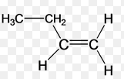if curly arrow from C₁-H,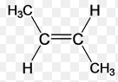or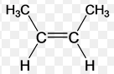if curly arrow from C₃-H
 | (b) | Any two of the alkenes shown for M3 not already awarded for M3  [5]
A4. | (a) | M1: Br₂ 2Br  M2: C₂H₆ + Br C₂H₅ + HBr  M3: C₂H₅ + Br₂ C₂H₅Br + Br
 | (b) | break Br-Br bond to form Br radical or homolytic fission (award mark for break Br-Br bond if radical shown in (a))
 | (c) | 1,2-dibromoethane or 1,1-dibromoethane or any other C2 molecule with 2 – 6 Br atoms or butane  [5]
A5. | (a) | M1: Curly arrow from lone pair of O on O-H to C on C-Cl, dipole on C=O (δ⁺- δ⁻), curly arrow from C=O to O (any 2)  M2: CH₃CCl(O⁺H₂CH₃)O⁻  M3: dipole on C-Cl (δ⁺- δ⁻), curly arrow from C-Cl to Cl, curly arrow from H-O to O (any 2)
 | (b) | M4: nucleophilic addition-elimination
 | (b) | M5: reaction violent or toxic HCl given off  [5]

Section B

B1. | (a) | M1: nucleophilic substitution or SN2 (not SN1)  M2 and M3: curly arrow from lone pair of O on O-H to C in C-Br, dipole on C-Br, curly arrow from C-Br to Br, both curly arrows shown simultaneously (all 3 = 2, any 2 = 1)  M4: CH₃CH₂CH₂CH₂OH, Br⁻ dipole on C-Br (δ⁺- δ⁻) (any 2) (can award species marks if shown in equation below)  M5: C₄H₉Br + OH⁻ C₄H₉ OH + Br⁻  M6: nucleophile  (6)
 | (b) | (i) | M1: (a) is SN2 but (b) is SN1  M2: Br leaves before nucleophilic attack in SN1 but at same time as nucleophilic attack in SN2
 |  | (ii) | M3: SN1 mechanism forms carbocation  M4: tertiary carbocations more stable than primary carbocations
 |  | (iii) | M5: Change [OH⁻] and measure change in rate  M6: changing [OH⁻] changes rate for SN2 but not SN1  (6)
 | (c) | M1: Elimination  M2, M3: curly arrow from lone pair on O in OH⁻ to H on H-C₂, curly arrow from H-C₂ to C₂-C₁, curly arrow from C-Br to Br (all 3 = 2, any 2 = 1)  M4: C₄H₁₀Br + OH⁻ C₄H₈ + H₂O + Br⁻  M5: base  M6: use ethanol as solvent + either higher temperature or distillation  (6)
 | (d) | (i) | M1: CH₃CH₂CHBrCH₃
 |  | (ii) | M2: Electrophilic addition
 |  | (iii) | M3: carbocation more likely on C₂ than C₁  M4: because secondary carbocations are more stable than primary carbocations  (4)
 | (e) | M1: C₄H₁₀ + Br₂ C₄H₉Br + HBr  M2: Br can substitute on any position or Br can substitute more than once  M3: So many other products formed  (3)  Total 25 marks

B2. | (a) | M1: electrophile = electron pair acceptor  M2: substitution = replacement of one atom or group of atoms by another  M3: π-bonds/ring/delocalised system in benzene is an area of high electron density  M4: which can donate a pair of electrons to electrophiles  M5: delocalised system makes benzene stable  M6: addition reactions would disrupt it/substitution reactions preserve it  (6)
 | (b) | (i) | M1: electrophile = C₂H₅⁺  M2: C₂H₅Br + FeBr₃ C₂H₅⁺ + FeBr₄⁻
 |  | (ii) | M3: Curly arrow from delocalised ring to C of C₂H₅⁺  M4: 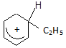 (crescent should cover 4 or 5 atoms, + not closer to C₁ than any other C)  M5: curly arrow from C-H towards ring or +  M6: H⁺ and C₆H₅C₂H₅  M7: ethylbenzene
 |  | (iii) | M8: H⁺ + FeBr₄⁻ HBr + FeBr₃
 |  | (iv) | M9 and M10: C₆H₄(C₂H₅)₂ with C₂H₅ on 1,2 or 1,3 or 1,4 or C₆H₃(C₂H₅)₃ with C₂H₅ on 1,2,3 or 1,2,4 or 1,3,5 etc (any 2)  (10)
 | (c) | (i) | M1: C₆H₆ + C₂H₄ C₆H₅C₂H₅
 |  | (ii) | M2: C₂H₄ + HBr C₂H₅⁺ + Br⁻ or C₂H₄ + HBr + FeBr₃ C₂H₅⁺ + FeBr₄⁻
 |  | (iii) | M3: FeBr₃ prevents Br⁻ from attacking the carbocation  M4: Which allows the benzene to attack the carbocation  (4)
 | (d) | (i) | M1: C₆H₅CH₂CH₂CH₃  M2: C₆H₅CH(CH₃)₂
 |  | (ii) | M3: C₆H₅CH(CH₃)₂  M4: Because the intermediate is a secondary carbocation or because the intermediate producing the minor product is a primary carbocation  M5: Secondary carbocations are more stable than primary carbocations
 |  | (iii) | M6: from 1-bromopropane or 1-chloropropane or CH₃CH₂CH₂Cl or CH₃CH₂CH₂Br  (6)  Max 25 marks

B3. | (a) | (i) | M1: lone pair on N can be donated  M2: C-Cl bond polar so C in C is δ^{+ve} in chloroalkanes (can award if dipole shown in (ii))  M3: C-Cl bond and/or C=O bond polar so C is δ^{+ve} in acid chlorides (can award if either dipole shown in (iii))
 |  | (ii) | M4: C₂H₅Cl + NH₃ C₂H₅NH₂ + HCl or C₂H₅Cl + 2NH₃ C₂H₅NH₂ + NH₄Cl  M5 and M6: curly arrow from lone pair on N in NH₃ to C in C-Cl AND curly arrow from C-Cl to Cl AND both shown simultaneously (all 3 = 2, any 2 = 1)  M7: C₂H₅NH₃⁺ and curly arrow from N-H to N
 |  | (iii) | M8: CH₃COCl + NH₃ CH₃CONH₂ + HCl or CH₃COCl + 2NH₃ CH₃CONH₂ + NH₄Cl  M9: curly arrow from lone pair on N in NH₃ to C in C=O AND curly arrow from C=O to O  M10: CH₃C(NH₃⁺)ClO⁻  M11: curly arrow from lone pair on O⁻ to C-O and curly arrow from N-H to N
 |  | (iv) | M12: C in ethanoyl chloride more δ^{+ve} because it is attached to two electronegative atoms (ORA) OR C=O π-bond weaker than C-Cl  (12)
 | (b) | (i) | C₂H₅Cl + CH₃NH₂ C₂H₅NHCH₃ + HCl or C₂H₅Cl + 2CH₃NH₂ C₂H₅NHCH₃ + 2NH₄Cl  M1: balanced equation  M2: correct structure of product
 |  | (ii) | M8: CH₃COCl + CH₃NH₂ CH₃CONHCH₃ + HCl or CH₃COCl + 2CH₃NH₂ CH₃CONHCH₃ + NH₄Cl  M1: balanced equation  M2: correct structure of product  (4)
 | (c) | (i) | M1 and M2: curly arrow from lone pair on C in CN⁻ to C in C=O, curly arrow from C=O to O, CH₃CH₂CHCNO⁻, curly arrow from lone pair on O to H⁺ (all 4 = 2 marks, any 2 = 1 mark)  M3: dipole on C=O (δ⁺- δ⁻), HCN H⁺ + CN⁻, CH₃CH₂CH(OH)CN (any 2)  M4: CH₃CH₂CHO + HCN CH₃CH₂CH(OH)CN
 |  | (ii) | M5: below pH 3 dissociation of HCN difficult so insufficient CN⁻ (for step 1)  M6: above pH 5 insufficient H⁺ (for step 2)
 |  | (iii) | M7: HCN very poisonous
 |  | (iv) | M8: H⁻  M9: C₃H₆O + 2[H] C₃H₈O or C₃H₆O + H⁻ + H₂O C₃H₈O + OH⁻  (9)  Total 25 marks

Section C

Answer one or two questions from this section.

C1. | (a) | (i) | What are aromatic compounds? Give four examples of aromatic compounds.
 |  | (ii) | State four characteristics of organic compounds.
 | (b) | Give the IUPAC names of the following compounds:
 |  | (i)  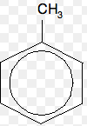 |  | (ii)  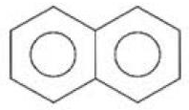 | (iii)  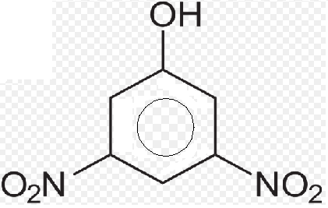
 |  | (iv)  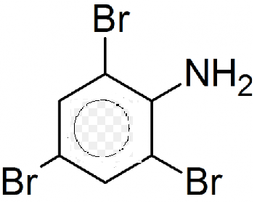 |  | (v)  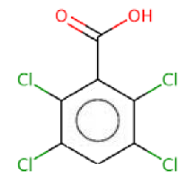
 | (c) | Draw the structures of the following compounds:
 |  | (i) | Amylopectin
 |  | (ii) | Amylose  Total 25 marks

C2. | (a) | Using an appropriate chemical equation, comment on the following methods of reducing the carbon chain length in aldoses:
 |  | (i) | Wohl’s method
 |  | (ii) | Rutt’s method
 | (b) | Give the products of the following reactions:
 |  | (i) | 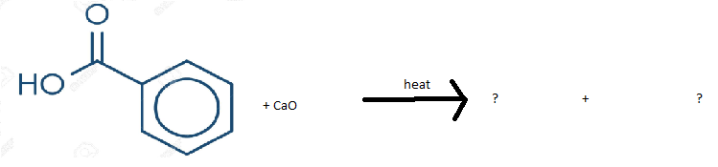
 |  | (ii) | C₆H₆ + HNO₃ ? + ?
 |  | (iii) | 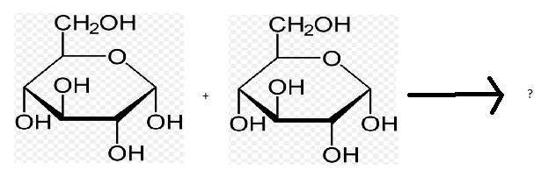
 | (c) | Give the structures of any four heterocyclic compounds.  Total 25 marks
C3. | (a) | (i) | What are essential amino acids?
 |  | (ii) | Give the structures of the following acids: arginine, phenylalanine, valine, tyrosine, proline.
 | (b) | (i) | Give the molecular formulae of the following fatty acids: lauric acid, stearic acid, palmitic acid, oleic acid, linolenic acid, linoleic acid
 |  | (ii) | What are osazones? Give the mechanism for the formation of an osazone.
 | (c) | Define the following carbohydrates and give two examples of each:
 |  | (i) | Glycosides
 |  | (ii) | Polysaccharides
 |  | (iii) | Disaccharides
 |  | (iv) | Monosaccharides
 |  | (v) | Oligosaccharides  Total 25 marks

END OF QUESTION PAPER

