EXTENDED PROTON NMR QUESTIONS
- The proton nmr spectrum of a molecule shows the following peaks:
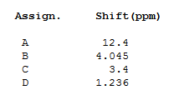
Peaks A and C disappear on shaking with D₂O.
The relative intensities of the four peaks are 1:1:1:3 respectively.
Can you identify the molecule?

- The proton nmr spectrum and mass spectrum of a molecule are shown below:
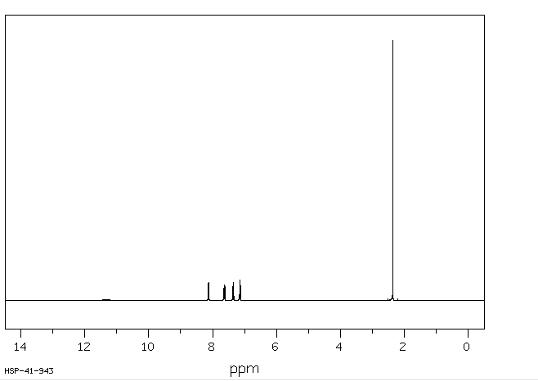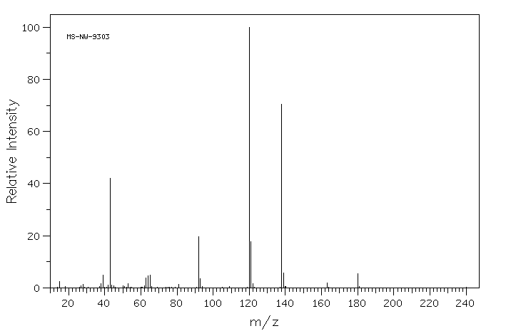
The peak at 11.4 in the proton nmr spectrumdisappears on shaking with D₂O
The relative intensities of the six peaks are, from left to right, 1:1:1:1:1:3.
Can you identify the molecule?

- Identify the two molecules A and B, giving reasons for your answer:
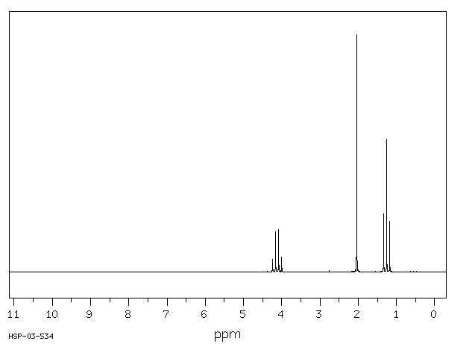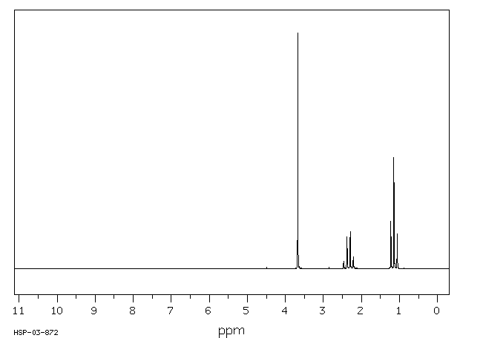
proton nmr spectrum of A proton nmr spectrum of B
(relative peak areas 2:3:3) (relative peak areas 3:2:3)

